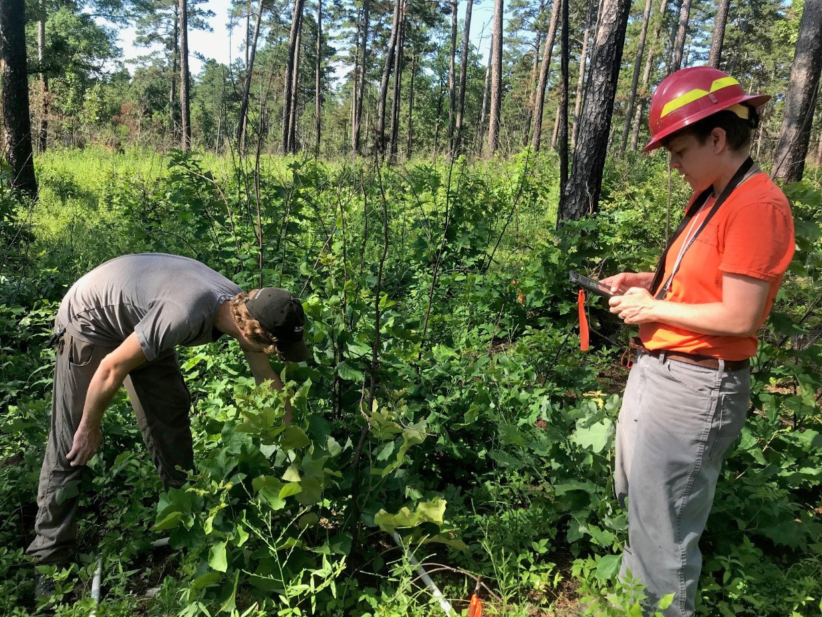

CFLRP 10 Year Results and Lessons Learned Summary Series
Shortleaf Bluestem Community, AR and OK

  - Leveraging Resources

The purpose of this document is to summarize the results and lessons learned from the “Leveraging Resources” theme in the comprehensive Collaborative Forest Landscape Restoration Program (CFLRP) 10 Years of Results and Lessons Learned report. Please review the report for details and resources.

Overview
CFLRP funding has been effectively used to leverage multiple local, regional, and national funding streams – including public and private funding – for restoration work on both Forest Service and private lands, to support the multi-party monitoring program, and provide employment and training opportunities to local youth. The strategic, place-based and long-term funding invested through CFLRP, leveraged with Forest Service funding and in-kind contributions, incentivized partners to contribute significant local funding to support restoration efforts on CFLRP landscapes. This leveraged funding not only expands our ability to create results together, it also reflects shared ownership in the results.

Key Results and Lessons Learned

To what extent does strategic federal investment in priority landscapes leverage partner resources?
- Between 2010 and 2019, CFLRP projects have attracted more than $470 million in partner investments across the CFLRP landscapes; $159 million of which supported work on National Forest Systems lands through grant funding, stewardship agreements, job training for youth crews, monitoring, and more. The additional public-private partnership funding includes work on other lands within the CFLRP landscape.
- For every dollar of CFLRP funding spent, CFLRP projects attracted $1.80 from partner investments.

FS (Forest Service) CFLRP funding are funds authorized by Congress and can be spent on implementation and monitoring on National Forest System (NFS) lands. Other FS funding includes Agency funds to support CFLRP projects across all lands. Partner match includes funding and in-kind contributions from partners to support CFLRP projects across all lands. Goods for Services represents the value of goods traded for services in stewardship contracts to implement treatments and monitor CFLRP projects on NFS lands.

What kinds of partners tend to provide leveraged capacity? What best practices emerged?

Contributions came from NGOs such as National Fish and Wildlife Foundation, Sierra Institute for Community and Environment, National Wild Turkey Federation, The Nature Conservancy, Trout Unlimited; youth educational programs such as Student Conservation Association, California Conservation Corps, Montana Conservation Corps; federal agencies such as US Geological Survey, Natural Resource Conservation Service, Bureau of Indian Affairs, National Park Service; state agencies such as California Department of Forestry and Fire Protection; Washington State Department of Transportation; universities such as Washington State University, California State University; municipal watersheds such as Upper Mokelumne River Watershed Authority and timber industries such as Iron Triangle Logging.

Project partners successfully leveraged multiple funding sources to accomplish restoration projects, support the multi-party monitoring program, and provide employment and training for local youth.
- To sustain future capacity, it’s critical to continue to invest in partner relationships and collaboration among all involved parties with meetings, field trips, outreach and technology transfer.
- CFLRP funding has been effectively used to leverage more funds and structuring funds/contracts to increase total capacity for restoration work on both Forest Service and private lands. Public-private funds expand the pace and scale of implementation through volunteer hours to complete treatment implementation from trail work to prescribed fire, and for monitoring, job training, and expertise.
- Projects were executed through mechanisms, including but not limited to service contracts, stewardship agreements, Challenge Cost Share Agreements, Master Participating Agreements and Supplemental Project Agreements for reforestation, thinning, mastication, burn preparation, piling of hazardous fuels and other treatments.

Are CFLRP projects more competitive for other funding sources?
- According to agency and stakeholder interviewees, partners were more willing to invest in the landscape with an initial investment and ongoing commitment from the Forest Service. Stakeholders said CFLRP funding made both the collaborative group and agency more competitive for additional funding sources. Many stakeholders noted they will rely on their increased competitiveness and landscape-focus initiated by CFLRP to continue competing for outside funding streams.
- The multi-year commitment to a place gives a landscape credibility and incentivizes partners to focus their capacity and leverage funding in a specific place.

Where to Learn More (selected resources from CFLRP Results and Lessons Learned)
- Description of local resources leveraged captured in CFLRP Annual Reports (Question 1)
- Additional project-level examples of leveraging local resources are available on the CFLRP Resource Library

Next Steps:
- Multi-year funding enables projects to leverage partner resources at the needed scale to make an impact. Commitment maintains projects as a priority and is a powerful “carrot” for getting to agreement and implementation. Leadership support, staff capacity, and partnership skills are key.
- Program staff are assessing ongoing challenges, identifying opportunities to address those challenges, and carrying out next steps with colleagues and partners

CFLRP Annual Reports: https://www.fs.fed.us/restoration/CFLRP/results.shtml
Ibid
“Strategies for Success Under Forest Service Restoration Authorities” https://ewp.uoregon.edu/sites/ewp.uoregon.edu/files/WP_81.pdf

