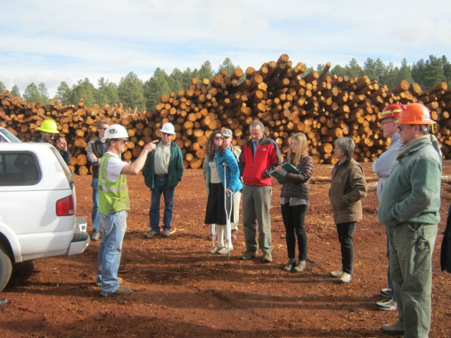

CFLRP 10 Year Results and Lessons Learned Summary Series
Four Forest Restoration Initiative, AZ

  - Community Benefits

The purpose of this document is to summarize the results and lessons learned from the “Community Benefits” theme in the comprehensive Collaborative Forest Landscape Restoration Program (CFLRP) 10 Years of Results and Lessons Learned report. Please review the report for details and resources.

Overview

CFLRP projects emphasize the connection between restoration, economic stability, and the social values communities hold. The community connection includes support for the forest products business and infrastructure, recreation and tourism, and engaging youth and the public in the management of their public lands. CFLRP participants commonly cite relationship building, locally retained contracts, partnership composition, job training opportunities, and cross institutional agreements as key community benefits. CFLRP projects create positive shifts in local support and provide capacity for restoration work.

Key Results and Lessons Learned

What economic and social benefits did CFLRP projects provide for, or encourage, in local communities?

Relationship Building and Collaboration
- The most common community benefit CFLRP projects selected in their 2019 annual reports was relationship building and collaborative work. This was cited by 16 projects (70%) as a key indicator.
- Five CFLRP projects (22%) cited public support for relevant initiatives as a community benefit. Examples of engagement that have led to good public understanding of processes and treatments include showing progress on the ground, conveying the project as an investment not a cost, keeping the management structure simple, managing expectations regarding requirements and timelines, etc.
- Cross institutional agreements/policies have allowed CFLRP projects to accomplish various types of restoration treatments with cooperators – seven projects (30%) selected this indicator as important for their CFLRP. Partners with whom agreements have been established include universities, state agencies, federal agencies, county agencies, non-government partners.
Jobs and Job Training
- Many collaboratives identified job enrichment and community stability as key desired outcomes for their CFLRP projects. Eight projects (35%) selected job training opportunities as a key benefit. Most of the job training opportunities were geared towards students, recent graduates and veterans through partnerships with programs such as Youth Conservation Corps and Student Conservation Association.
- CFLRP Project activities supported an average 5,440 jobs annually (full and part time jobs).
Supporting the Local Forest Products Industry
- Ten of the CFLRP projects (44%) selected locally retained contracts as a key community benefits indicator. Project-level monitoring indicates mixed results in terms of local contract capture..
- Forest products coming from the CFLRP area help support the forest products industry, and can result in multiple timber sales and the sales may take several years to complete. This steady flow of timber from Forest Service sales combined with timber coming from other ownerships is critical to maintaining the local timber infrastructure and supporting local timber jobs.

Contributions to the Recreation and Tourism Economy
- In some cases, CFLRP projects reported that their work helped support recreation and tourism opportunities.
Tribal Connections
- Five projects (22%) cited tribal connections as an important community benefit for their project areas.
Volunteer participation
- Five projects (22%) cited volunteer participation as an important community benefit indicator. Activities with volunteers have led to trail maintenance and improvements, litter clean up, public education, campsite inventory, monitoring. Volunteers assist in monitoring through citizen science.
- Expanded volunteer opportunities support career mentoring and education while delivering results.

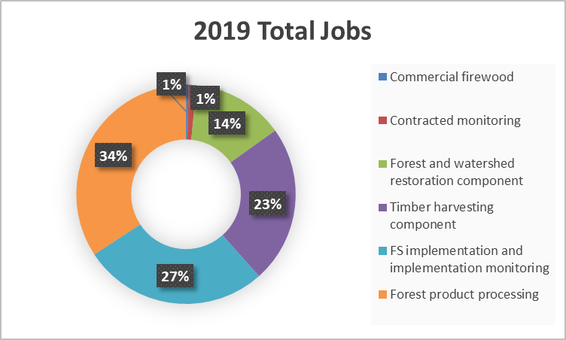
What kinds of restoration and related activities provided benefits?
- CFLRP supports jobs in multiple sectors, including forest product harvesting and processing, commercial firewood, contracted restoration implementation and monitoring.
- Restoration activities include non-commercial thinning, road decommissioning, aquatic organism passage installation, road maintenance, recreation improvements, weed eradication, fish and wildlife monitoring, trail work, tree planting, native fish restoration, citizen science stream monitoring, aquatic invasives inspections, and carnivore monitoring.
Commercial firewood includes jobs from the sale of firewood harvested. Contracted monitoring includes jobs from private business. Forest and watershed restoration jobs includes contracted restoration activities. Timber harvest contributions include jobs from logging and removal of commercial products. FS implementation and monitoring includes contributions from Agency implementation and monitoring. Forest product processing includes jobs from processing of commercial harvest.
- Some restoration projects are heavily dependent on work accomplished by volunteers and partners.

What did we learn about expanding markets for biomass/small diameter woody material and building local industry capacity?
- Forest industry capacity and markets is an important consideration for landscape-scale restoration. Through a collaborative approach, CFLRP projects can create a social license and expanded capacity to explore new opportunities and technologies. Five projects (22%) cited economic dependency/sectors impacts/expanding market development as a community benefit.
- While CFLRP projects helped maintain and, in some cases, expand existing industry, projects reported a lack of infrastructure and markets for low-value wood products as a continuing challenge.
- Several CFLRP projects worked to assess new opportunities and technologies to expand markets and infrastructure, including new products and processing approaches.
- CFLRPs used a suite of tools and approaches to support local forest products industry and expand markets, including offering multiple scales and contract types. Stewardship grants and agreements may be a path forward for many projects to keep the work – and local industry- viable, along with defining “local” community benefit appropriately when awarding contracts. However, one size doesn’t fit all.

Where to Learn More (selected resources from CFLRP Results and Lessons Learned)
- Information on the Treatment for Restoration Economic Analysis Toolkit (TREAT), a modeling tool used to estimate jobs supported and local labor income across CFLRP projects
- Project TREAT data (Question 3) and description of community benefits (Question 4) is available in CFLRP Annual Reports
- Assessing, Planning, and Monitoring to Increase Local Economic Opportunities from Restoration
- Social and Economic Monitoring for the Lakeview Stewardship CFLRP
- Regional Economic Contributions of the Four Forest Restoration Initiative
- Additional CFLRP project-level social and economic monitoring reports are posted to the CFLRP Resource Library

Next Steps:
- Forest restoration and community benefits are closely linked. CFLRP projects provide a variety of benefits to communities in a variety of ways.
- Additional work is needed to fully contextualize community benefits across communities and better understand and monitor social and economic benefits. There is an opportunity to improve socioeconomic information about the program.
- Recognizing that the lack of wood products contractors or markets is commonly cited as one of, or the, most important external factors that limited CFLRP success, additional work and focus is needed to address the challenges and barriers.
- Program staff are assessing ongoing challenges, identifying opportunities to address those challenges, and carrying out next steps with colleagues and partners for each Level 2 theme and across them as well.

