**Divide Allotment 2020 End of Year Report**

**NMFS BO No: NWR-2012-3954**

Wallowa-Whitman National Forest

Wallowa Valley Ranger District

January 2021

Introduction: The purpose of this report is to satisfy Terms and Conditions set forth in the Biological Opinion from NMFS, NWR-2012-3954, and USFWS, 01EOFW00-2012-F-0105. This report will cover the grazing activities and results from a variety of monitoring and adaptive management conducted during the 2020 grazing season.

**Terms and Conditions**

1. To implement reasonable and prudent measure # 1 (take on SRB steelhead due to extended cattle access), the WWNF shall:
   1. Construct the fencing, as proposed, for the Little Sheep Riparian Pasture before cattle turn out in calendar year 2014. The portions of the proposed fencing along the Divide-Marr Flat boundary and around Salt Creek are not part of the fencing that is being constructed to create the Little Sheep Riparian Pasture.

- The Little Sheep riparian fence was built in 2013 and is 3.5 miles long. Cattle guards were replaced in 2014 making the fence work as designed. The fence was monitored annually from 2013-2020. Construction of the fence created the Little Sheep Creek riparian pasture. No grazing is planned within the Little Sheep Riparian Pasture.

Maintain and ensure proper operation of all exclosure structures, such as fences, designed to protect SRB steelhead spawning and rearing. There was significant damage to the fence from snow breaking wires during the 19-20 winter. This was repaired by the Permittee

-The Divide allotment contains the Carrol Creek. exclosure fences. In 2016 a ¼ mile portion identified downstream of the existing exclosure was built. In 2017 an additional ¼ mile upstream of the existing enclosure was built. In 2018 an additional 1/2 mile of enclosure fence was constructed. These fences exclude grazing from the entire steelhead spawning reach in Carrol Creek.

-In 2020 deteriorating rock jacks, sinking T-post and a broken gate post allowed cattle into 1 of 3 enclosures. Use within the enclosure exceeded bank alteration and stubble height limits. Photos of use within the enclosure are shown in Figure 1 on page 2 and 3. It is the intent of the Forest Service and the Permittee to reconstruct this enclosure.

1. To implement reasonable and prudent measure #2 (take on SRB steelhead due to streambank alteration), the WWNF shall:
   1. Consistently implement grazing-related standards and guidelines to achieve RMOs regarding bank stability, water temperature, large woody material, lower bank angle, width/depth ratio and other aquatic habitat parameters that may be affected by livestock grazing.

-In 2020 deteriorating rock jacks, sinking t post and a broken gate post allowed cattle into 1 of 3 enclosures. Use within the enclosure exceeded bank alteration and stubble height limits. Photos of use within the enclosure are shown in Figure 1 on page 2 and 3. It is the intent of the Forest Service and the Permittee to reconstruct this enclosure in 2021.

**Figure 1.** Photos of grazing within enclosure on Carrol Creek

PHOTO 1: Within Carrol Creek enclosure on 25 September.

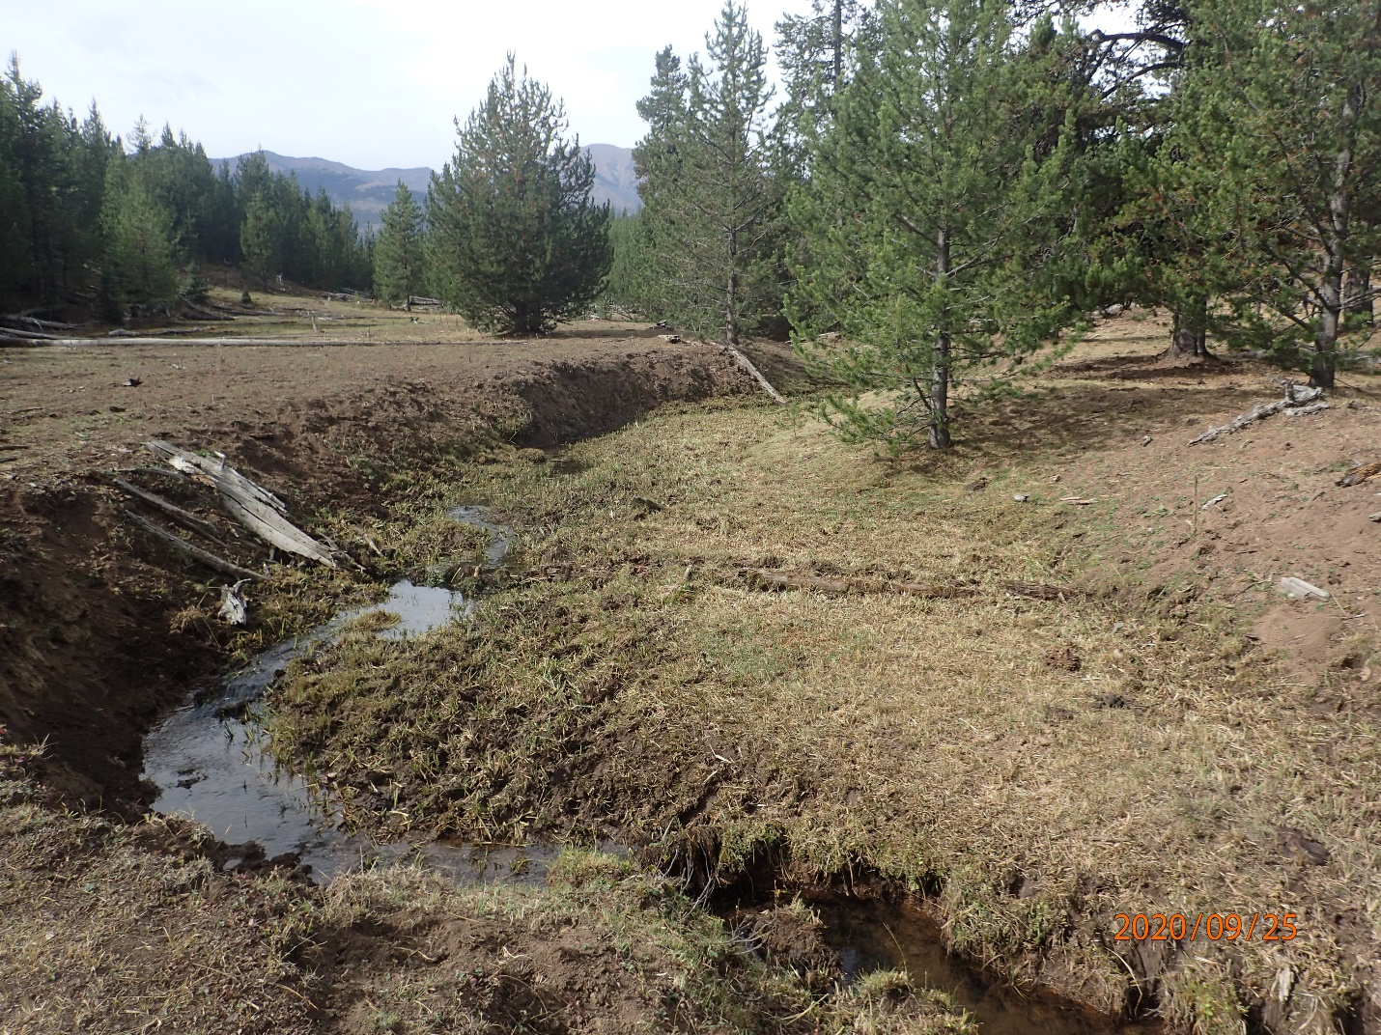

PHOTO 2: Broken gate post allowing cattle into enclosure.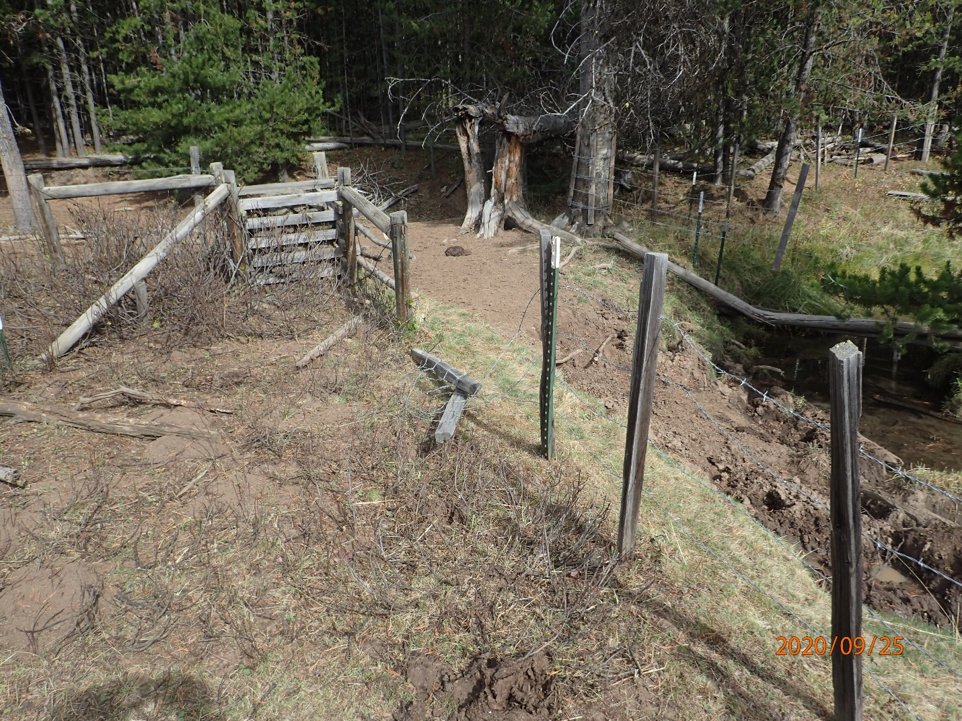

* 1. If current utilization standards are insufficient to prevent less than 40% unwanted browse of shrubs or keep bank alteration at or below 20%, change the utilization standard for that pasture to facilitate meeting allotment objectives. The planned fencing to exclude grazing from the steelhead spawning reach will address this T&C.

-In 2018 All of the accessible steelhead habitat on Carrol Creek was fence out.

1. Ensure that the permittee is aware of WWNF’s resource objectives and the indicators WWNF is concerned with (stubble height, woody utilization, and bank alteration) and that the permittee knows how to monitor for those indicators.

-The AOI was communicated to the permittee on 05 May 2020. The AOI contains the utilization standards and resource objectives.

1. To implement reasonable and prudent measure #3 (monitoring and reporting), the WWNF shall ensure that the following monitoring information is collected and reported to NMFS:
   1. Carry out all proposed monitoring, including MIM monitoring for bank alteration.

- This area is excluded by enclosure fence that was completed in 2018.

* 1. Provide an end-of-year report to NMFS by February 15 of each year. The following shall be included in the report for the Divide Allotment:
     1. Actual authorized head months.

-In 2020 976 head months were permitted. Approximately 863 head months were utilized.

* + 1. On/Off Dates

## 

**Table 1.** Actual 2020 On/Off Dates

|  |  |  |  |  |  |  |
| --- | --- | --- | --- | --- | --- | --- |
| **Pasture** | **Head** | **June** | **July** | **Aug** | **Sept** | **Oct** |
| North Target Springs * | 175 | 30- | -31 |  | 11- | -21 |
| White Horse* | 50 | 15- | -31 |  |  |  |
| Hepburn* |  |  |  |  |  |  |
| Middle Target Springs* |  |  |  |  |  |  |
| South Target | 225  50 |  |  | 1- | -10  11- | -21 |
| Little Sheep Riparian | No planned use | | | | | |
| Holding | As needed to manage cattle | | | | | |
| Cow Camp Horse Pasture | 3 H/M | 11- | - | - | - | -21 |

## *Contains listed fish species

* + 1. Results from all monitoring identified as part of the proposed action, to include utilization, unauthorized use, and compliance monitoring, to include any exceedance of endpoint indicators.

**Table 2.** 2015 and 2016 Utilization Standards Data

|  |  |  |  |  |  |  |  |  |  |
| --- | --- | --- | --- | --- | --- | --- | --- | --- | --- |
| **Pasture/**  **Key Area** | **Date** | **GLSH** | **GLSH Std.** | **WB** | **WB Std.** | **BA** | **BA Std** | **RTSH** | **RTSH Std** |
| Target Spring pasture- lower Carrol Creek monitoring area | Fence has been constructed to enclose the spawning habitat of Carrol Creek that is within the Divide Allotment. This fence was completed in 2018. | | | | | | | | |
| South Target  K3A Riparian monitoring area | Fence has been constructed to enclose the spawning habitat of Carrol Creek that is within the Divide Allotment. This fence was completed in 2018. | | | | | | | | |

*Woody browse not available for grazing or is not present

GLSH: green line stubble height

Std: Utilization Standard

WB%: woody browse percent utilization

BA: bank alteration

RTSH: riparian terrace stubble height

* + 1. Review of management and compliance successes and failures.

-The steelhead spawning reaches of Carrol Cr were excluded from grazing in 2018.

- In 2020 the fence on the old enclosure failed and allowed cattle to graze within this enclosure for some time in September. The cause was deteriorating rock jacks, sinking t post and a broken gate post allowed cattle into 1 of 3 enclosures. Use within the enclosure exceeded bank alteration and stubble height limits. Photos of use within the enclosure are shown in Figure 1 on page 2 and 3. It is the intent of the Forest Service and the Permittee to reconstruct this enclosure.

- In 2020 The Permittee constructed a fence that divides the allotment into a north and south half of the allotment. The map has not been updated because of GPS software issues. It starts on the west side of the Carrol Creek enclosures and goes about 1.5 miles to the fence that is just east of the 3900 road. Additional fence was also constructed at the mouth of Salt Creek to distribute cattle back into the Divide Allotment.

* + 1. Results of implementing and completing long-term trend monitoring using appropriate methodology needed to identify trends for riparian ecosystems on streams containing ESA-listed fish within the allotment.

- The steelhead spawning reaches of Carrol Cr were excluded from grazing in 2018.

* + 1. Compliance with each pertinent term and condition contained in this opinion.

- The steelhead spawning reaches of Carrol Cr were excluded from grazing in 2018.

* + 1. Review of adequacy of monitoring program for determining habitat condition and trends.

- The steelhead spawning reaches of Carrol Cr were excluded from grazing in 2018.

* + 1. Management recommendations for subsequent years.

-Reconstruct the middle (oldest) enclosure on Carrol Creek in 2021

* + 1. Multiple Indicator Monitoring data, including stream bank alteration.

-See Table 2. The steelhead spawning reaches of Carrol Cr were excluded from grazing in 2018.

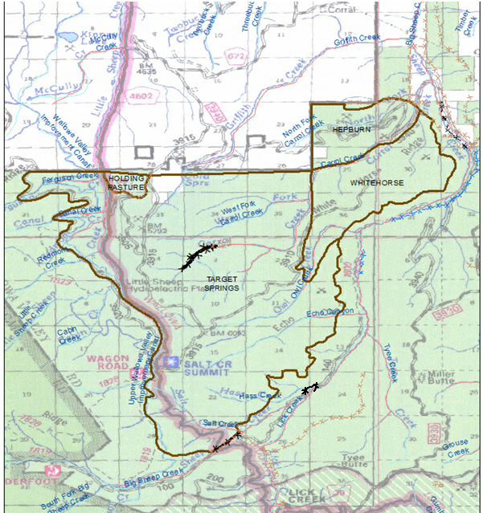

MAP 1: Fences constructed in 2018 and 2019.