

**SCALE EXPANSION PROGRAM**

**USER’S GUIDE**



Washington Office

Forest Management Service Center

Fort Collins, Colorado

The U.S. Department of Agriculture (USDA) prohibits discrimination in all its programs and activities on the basis of race, color, national origin, sex, religion, age, disability, political beliefs, sexual orientation, or marital or family status. (Not all prohibited bases apply to all programs.) Persons with disabilities who require alternative means for communication of program information (Braille, large print, audiotape, etc.) should contact USDA’s TARGET Center at (202) 720-2600 (voice and TDD).

To file a complaint of discrimination, write USDA, Director, Office of Civil Rights, Room 326-W, Whitten Building, 1400 Independence Avenue, SW, Washington, DC 20250-9410 or call (202) 720-5964 (voice or TDD). USDA is an equal opportunity provider and employer.

Introduction 4

Who to call 4

MAIN MENU 5

CONNECT DATABASE 6

OPEN CONTRACT 8

NEW CONTRACT 9

EDIT CONTRACT 12

ISSUE TICKETS 13

CONTRACT SPECIES 15

SAMPLE GROUP 17

ADDING SCALED/UNSCALED LOADS 20

EDITING SCALED/UNSCALED LOADS 27

SCANNING LOADS 30

ORPHAN LOADS 32

REPORTS 34

Summary Reports 35

Audit Reports 38

Periodic Volume Report 42

Quarterly Summary Report 47

Missing Load Logic 50

Frequency Calculation Report 52

IMPORT FILES 54

FSscaler Program 55

R1 Scale 55

R2 Scale 55

R4 Scale 55

Sample Selection 56

TOOLS 58

Password Maintenance 58

Archive Functions 60

Remove Orphaned Loads 61

Review Periodic Volume 61

Make Backup 63

Appendix A – Reports 64

REPORT EXAMPLES 65

Appendix B – Set Dates 72

Appendix C – Scale Sync 74

# Scale Expansion program logoIntroduction

The Scale Expansion program is an important tool for recording scaled load information. This information is ultimately transferred to the Timber Sale Accounting system to provide the volume transactions needed to produce the monthly volume changes. Scale expansion reports are part of the official scale records to be kept with the timber sale contract per FSH 2409.15. A few of the features in the program include entering a new contract, creating ticket book records for that contract, creating new sample groups and contract species for the sale, entering individual log load receipts as they come in, editing entered information, importing data from other sources, archiving a sale and general maintenance.

Idea light bulbThis symbol represents an idea, tip or hint to aid the user through a screen or process. These items are not necessary to successfully complete a given process but will make it faster or easier.

Pencil representing a note

This symbol represents a note and offers additional clarification or definition. Not reading the note would not be harmful.

Warning symbolThis symbol represents a potential problem or serious issue.

## Who to call

Telephone imageQuestions, comments, problems, or just want to talk? Here’s two people who would like to hear from you:

Ken Cormier, Group Leader, Measurements Group

Phone: 970-295-5779

email: [kcormier@fs.fed.us](mailto:kcormier@fs.fed.us)

# MAIN MENU

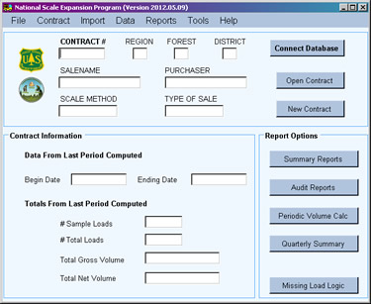

***Toolbar Menu***

*Main information display for contract.*

***Contract Information*** *displays any data from last period computed.*

***Report Options*** *includes Summary Report and Audit Reports as well as other reports.*

When the program is started, the **Main Menu** is displayed. The window contains four main areas. Along the very top of the window is a toolbar containing all available functions in the program. Each is described a little later in this guide.

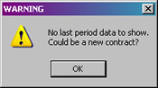The top box contains three buttons, **Connect Database**, **Open Contract**, and **New Contract**. These buttons provide quick access to the respective function instead of using the toolbar. Additionally, basic information about the currently open contract is displayed to the left of these buttons.

The **Contract Information** box contains last period data when a contract is opened. If there is no last period data for the contract, a warning is displayed indicating it could be a new contract and no data are available to display.

On the right side of the window is the **Report Options** box. This contains buttons to access the various reports available and is similar to the list under *Reports* on the toolbar. Reports are discussed later in the user’s guide.

# CONNECT DATABASE

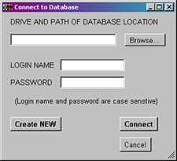

*Displays the path and filename. May be shortened to fit the box.*

*User enters name and password here.*

*The* ***Connect*** *button connects the database displayed at the top.*

*New empty database file may be created using the* ***Create NEW*** *button.*

No action can be taken without first opening the database file or creating a new file (not a new contract). This requires a user name and a user password.

#### Opening an existing database file

There are two ways to open a database file.

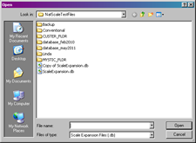

**If users have placed the database file on the T: or O: drive, it is strongly recommended the file be placed on a local PC drive while working on it and then store it on the T: or O: drive when work is completed.**

First, the user can browse for the file by following these steps:

1. Click the **Connect Database** button (alternatively, click *File* in the toolbar then *Connect Database*). The Connect Database window opens.
2. Click the **Browse…** button to open the standard browse window.
3. Select **ScaleExpansion.db** to open.

**Warning symbolThere is only one database file associated with the program--ScaleExpansion.db. Any other selection may have serious unknown consequences. DO NOT RENAME THIS FILE.**

1. Once the selection is made, the file name and partial path name is displayed in the top box.
2. The user must enter a valid login name and password in the appropriate box.
3. Click the **Connect** button to open the database.
4. A message is displayed welcoming the user to the system. Click **OK** to close the message. The database is now open.
5. The **Cancel** button may be used to close the window without opening a file. A warning message (“Database not connected”) is displayed. Click **OK** to close the message.

The second method for opening the file involves starting the program from the command line and including the fully qualified filename (path and filename). This can be done using the script outlined in **Appendix C**. Alternatively, by opening Windows Explorer and navigating to where the database file is stored and having the program icon on the desktop, the file may be dragged and dropped on the icon and the program starts. When Connect Database is clicked, the filename automatically shows in the box at the top.



#### Creating a new empty database file

Don’t confuse this with creating a new contract within the database. This is used to create an empty database file (ScaleExpansion.db) when none exists anywhere on the system.

Create a new file with these steps:

1. Open the Scale Expansion program.
2. Click on the **Connect Database** button (or select *File* from the toolbar and then *Connect Database*).
3. 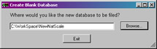Without entering the login name, password or database location, click the **Create NEW** button.
4. The next window allows the user to browse for where the database file is to be stored. Initially, make this a local PC drive. When the database is not in use, it may be stored on the T: or O: drive.
5. 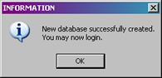Click the **Browse…** button to select the path.
6. Once complete, a message is displayed and clicking **OK** closes the message window.
7. At the **Connect to Database** window, the complete filename is shown in the box at the top and the user may now login.

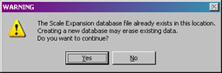***If the ScaleExpansion.db file exists in the directory selected, a warning message is displayed. Creating an empty database in the same location does overwrite the existing file which erases all the data in that file. Be careful how you answer this question!***

# OPEN CONTRACT

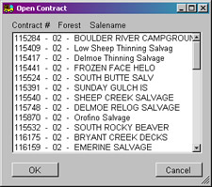

*All contracts in the database are listed by number, forest and salename. Click (or double click) on the contract to open.*

*Click the* ***OK*** *button to open the contract selected.*

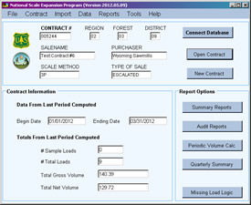

*Contract information is displayed on the Main Menu. Any last period data is displayed in the* ***Contract Information*** *box.*

Before any data is entered or edited for a sale, the contract must be opened. To open an existing contract, click the **Open Contract** button on the **Main Menu** (alternatively, select *Contract* then *Open Contract* from the toolbar).

The **Open Contract** window (shown at top) is displayed. This window shows all available contracts in the database listed by contract number, forest number, and sale name. The user can scroll through the list using the arrows and/or bar on the right side to find the desired contract. Simply click on the contract to open and then click the **OK** button at lower left. Alternatively, double click the contract and it opens without having to click the OK button. The Main Menu is updated with the opened contract information.

# NEW CONTRACT

*User enters contract number, region, forest, district, and salename.*

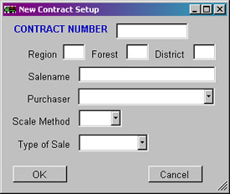

*Pulldown list of* ***purchasers***

*Pulldown list of* ***scale methods***

*Pulldown list for* ***type of sale***

The **New Contract Setup** window is displayed when the **New Contract** button is clicked on the Main Menu (alternatively, select *Contract* from the toolbar then *New Contract*).

To enter a new contract, the user simply enters the contract number, region, forest and district as well as the salename.

***Contract Number –*** This is the number assigned to the sale. It is **six digits** in length with preceding zeros if less than six digits. For example: A contract number of 3478 is entered as 003478. If the number is less than six digits in length with no preceding zeros, ScaleExpansion adds the preceding zeros.

***Region, Forest and District –*** Enter the two digit numeric code for each of these items. For example, Region 2 is recorded as 02. Forest 5 is recorded as 05 and District 3 is recorded as 03.

***Salename –*** Salename is a descriptive field for the sale containing up to 25 characters.

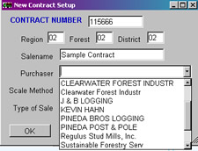***Purchaser –*** The program searches the database for all the purchasers used in the various contracts and populates the pulldown list with those purchasers. If the purchaser for this new contract is not listed, the user may type the purchaser name in the box. Additionally, if the database is empty, the purchaser list is empty and purchaser names must be typed in.

*Pencil symbolIf purchaser names were entered for the various contracts in different formats, those will all show up in the list. Take your pick!*

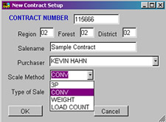***Scale Method –*** Describes the sampling method applied to the scale loads. Four scaling methods are available in ScaleExpansions: **3P, CONV, WEIGHT and LOAD COUNT**. Scale method is also a pulldown list which allows the user to pick the appropriate method for the contract.

Scaling applications use a two-stage sample design. The first stage determines which of the hauled loads will be sample loads. The first stage sample is based on a sample load or a sample weight. Determining between sample load and sample weight is accomplished through defining sample groups. The second stage determines which logs in a sample load are measured for volumes. ScaleExpansion currently handles four scale methods:

***3P Scale***: An estimate is made for the volume of each log in a sample load. This estimate is checked against a random number. If the random number is equal to or smaller than the estimated volume, the log is scaled. Otherwise, just the estimated volume is recorded.

***Conventional or 100% scaling***: All logs in a sample load are scaled.

***Weight Scale***: Every hauled load is weighed and either a conversion factor is applied to those weights to calculate the volumes or the volumes are displayed in tons. This is not really a two stage sampling design but a 100% sample for loads weights.

***Load Count Scale***: A load count value is established for each sample group in the sale and is applied to the number of loads for the period. It is usually used for very low value material and none of the loads are scaled. Multiple species are allowed but need to be separated into sample groups with an associated load count value for each.

Every contract is scaled according to one Scale Method. If using sample groups and a 3P scale for one sample group and a Weight scale for a second sample groups, two separate sales are identified with the volumes combined together manually at this time.

Example: A sale has Ponderosa pine sawtimber and also includes aspen non-saw logs. The pine is scaled using the 3P method. However, the aspen is weighed and paid for using an established weight factor of 50 pounds per cubic foot. The pine might be setup using the original contract number of 001234. The aspen could be setup using a contract number of 011234. The aspen information from the TSA file would have to be added into the TSA file for the pine.

***Type of Sale –*** Type of Sale refers to the time frame for which the scaled volumes get expanded. There are two methods available in ScaleExpansion:

***Flat Rate***: All volumes are expanded cumulatively over the life of the sale. The user defines the ending date for the period (usually this is the end of every month) and all loads hauled and sampled up to the ending date are included in the volume expansion to determine the Contract to Date Volume. Once the volume to date has been calculated, the volume to date from the previous expansion period is subtracted off leaving the volume cut for the period or month.

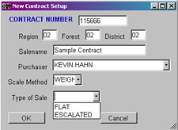***Escalated***: Escalated sales work on a quarterly basis, with each quarter standing on its own. Volumes are expanded using the first day of the quarter as the beginning date. The user defines the ending date for the period (usually the end of the month) and all loads hauled and sampled between the beginning date (beginning of the quarter) and the ending date (month end) are included in the volume expansion to determine the Quarter to Date Volume. If it is the first month in the quarter, the quarter to date volume is also the volume for that period or month. If it is the second or third month in the quarter then the quarter to date volume from the previous month is subtracted off leaving the volume cut for that period or month.

Both Flat Rate and Escalated sale work with all the scale methods listed above.

The Type of Sale is also selected from a pulldown list.

When the form is complete to the user’s satisfaction, clicking the **OK** button ensures the contract number is not already entered in the database. A warning message is shown if the contract number has previously been entered. Otherwise, all entered information for the new contract is saved to the database.

# EDIT CONTRACT

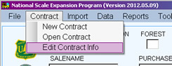

***Edit Contract Info*** *is only available from the toolbar.*

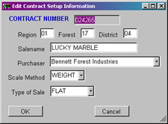

*Contract information for the currently open contract is displayed for editing.*

Editing contract information is easily done by selecting *Edit Contract Info* from the toolbar menu under *Contract*. All the contract information is displayed in the **Edit Contract Setup Information** window. Simply change those items requiring modification and click the **OK** button when finished. All changes are then saved. If the main window information does not update, simply open the contract again.

***Adding data to a Contract*** – There are several different types of information to be entered for a contract. The data types are grouped into four main categories: Tickets Issued, Contract Species, Sample Groups and Adding or Editing Loads.

Adding Contract Species and Samples Groups are done just one time per contract. Tickets Issued are updated regularly. Adding new scaled/unscaled loads is by far the most time intensive data entry task but can be primarily done through electronic import.

Steps for entering each category of data are detailed below.

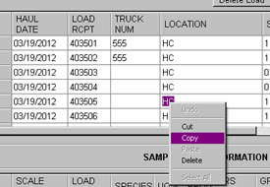

Most of these windows use a grid for displaying information already entered. It is possible to copy and paste data from one grid cell to another. Highlight the data to be copied, right click with the mouse and select Copy. Click on the grid cell where the data is to be copied to, right click and select Paste.

# ISSUE TICKETS

*Click this button to* ***add new tickets****.*

*Click this button to* ***close the window and save the data****.*

*Click this button to* ***delete a row****.*

*Currently* ***open******contract****.*

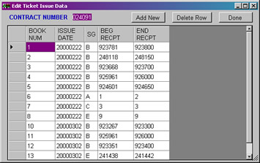

*Use scroll bar to move the list.*

*Books already associated with the currently open contract are displayed.*

*Use the mouse to pull this corner to make the window bigger.*

***Adding New Tickets***

Adding books to a contract is easily done in the **Edit Ticket Issue Data** window. Follow these steps for adding new ticket books.

1. 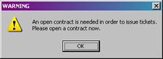After connecting to a database file, click **Open Contract**.
2. Select the contract to open and work with.
3. On the toolbar, select *Data* then *Issue Tickets*. If a contract was not opened, a warning message is displayed. Essentially, go back to step 1.
4. If step 3 was successful, the **Edit Ticket Issue Data** window (shown above) opens.
5. 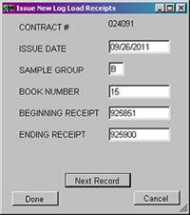To add a new ticket book, click the **Add New** button.
6. The **Issue New Log Load Receipts** window opens with the currently open contract number at the top and the current date supplied as the issue date. The contract number cannot be changed but the user may change the issue date if desired.
7. On the rest of the window, the user enters the sample group, book number, and beginning and ending receipt numbers. Use the **TAB** or **SHIFT TAB** keys to move between fields. The book number is checked to ensure it has not already been assigned to a contract. The example shows a completed window.
8. To add more books, simply click the **Next Record** button and the window resets, ready for a new set of receipts.

*Pencil symbolIf multiple books are to be entered, it is not necessary to click the* ***Done*** *button after each book is entered. Clicking* ***Next Record*** *allows this window to remain open until all books are entered. The* ***Done*** *button closes this window and returns to the previous Tickets Issued window.*

1. 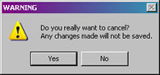When the user has finished entering books, click the **Done** button to close the window and save the data entered.
2. 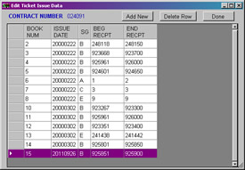If the **Cancel** button is clicked, a confirmation window is displayed. If this was the user’s intention, click the **Yes** button. Be aware that this action does **NOT** save any data entered. Otherwise, click the **No** button.
3. New books entered now appear in the original window as shown in this example.

When all data has been entered, click the **Done** button in the upper right corner to close the window. All data is now saved in the database.

**Pencil symbol***Sample Group is used if loads from the sale are going to more than one location or the sale has different products, units of measure, or species which are going to be sorted by loads. A blank sample group is allowed (must be one space and not just empty).*

*Pencil symbol*

**NOTE: Log load receipts are kept track of by book number.**

**Warning symbolNOTE: Clicking the X button in the upper right corner also closes the window. However, no confirmation window is displayed and no data entered is saved.**

***Editing Ticket Data***

To edit ticket information, simply modify the data shown in the grid. Click in the desired cell and enter the new information. When finished, click **DONE** to close and save the changes.

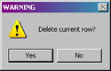

To delete an entry, click on the row to delete and then click the **Delete Row** button. The row is removed from the display. Clicking **DONE** save the changes and closes the window.

# CONTRACT SPECIES

*Click this button to* ***close the window and save the data****.*

*Currently* ***open******contract****.*

*Click this button to* ***delete a row****.*

*Click this button to* ***add new contract species****.*

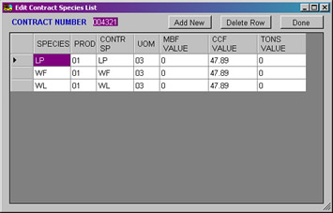

*Use scroll bar to move the list if needed.*

*Contract species already associated with the currently open contract are displayed. This example currently has three contract species entered.*

*Use the mouse to pull this corner to make the window bigger.*

***Adding New Contract Species***

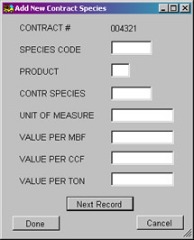Entering **Contract Species** for a contract looks very similar to the windows for issuing tickets. It has the same buttons at the top and shows a list of the contract species already entered for the currently open contract. To open the **Contract Species** window, select *Data* from the toolbar and then *Contract Species*. If no contract was opened, a warning is displayed requesting the user go back and open a contract.

The steps to enter contract species are similar to those for entering new ticket books. The difference is in the information collected. When the **Add New** button is clicked, the **Add New Contract Species** window is displayed. The currently open contract number is displayed at the top and cannot be changed. The user enters the species code, product, contract species code, unit of measure, value per MBF, CCF or Ton as applicable. Use the **TAB** or **SHIFT TAB** keys to move between fields.

Like the Issue Tickets window, clicking the **Next Record** button clears the window for more entries. The **Done** button closes the window and saves the data. The **Cancel** button confirms this is what the user wants to do.

**Species Code** is case sensitive and needs to be identical to the species code used by the scalers. To follow TSA guidelines, species code should always use capital letters and follow TSA defined codes.

**Value Per MBF,** **Value Per CCF** and **Value Per Ton** are used when calculating a sampling frequency based on value and/or using the missing load logic to determine the highest value sampled load for the quarter or sale to date. These values are not to be used as part of the TSA transaction file and are ***never*** used for the purposes of billing.

**Warning symbolNOTE: Clicking the X button in the upper right corner also closes the window. However, no confirmation window is displayed and no data entered is saved.**

***Editing Contract Species Data***

Editing data for Contract Species is similar to editing Ticket Data. Simply click on the desired cell and enter the new information. When finished, click **DONE** to close and save the changes.

To delete an entry, click on the row to delete and then click the **Delete Row** button. The row is removed from the display. Clicking **DONE** saves the changes and closes the window.

**Warning symbol*NOTE: When database files were converted from NatScale to ScaleExpansion, contract species value defaulted to the species code stored in this table. The user may correct the contract species as needed.***

# SAMPLE GROUP

*Click this button to* ***close the window and save the data****.*

*Click this button to* ***delete a row****.*

*Click this button to* ***add new sample groups****.*

*Currently* ***open contract****.*

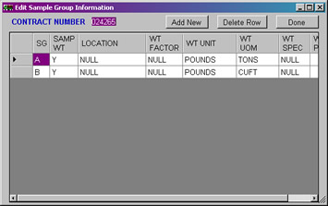

*Use scroll bar to move the list if needed as the list grows.*

*Sample groups already associated with the currently open contract are displayed. This example currently has two sample groups entered.*

*Use the mouse to pull this corner to make the window bigger.*

*The bottom scroll bar moves the list left or right.*

***Adding New Sample Groups***

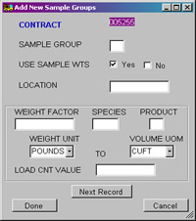Entering **Sample Groups** for a contract is similar to entering contract species or ticket books. It has the same buttons at the top and shows a list of sample groups associated with the currently open contract. The data displayed is different and may extend beyond the edge of the window. The window may be expanded by clicking the mouse on the lower right corner and dragging. To open the Edit Sample Group Information window, select *Data* from the toolbar and then *Sample Group*. If no contract is open, a warning is displayed requesting the user go back and open a contract.

The steps to enter new sample groups are similar to those for entering ticket books or contract species. The information collected is different. When the **Add New** button is clicked, the **Add New Sample Groups** window is displayed. The currently open contract number is displayed at the top and cannot be changed. The user enters the sample group, whether sample weights are used, location, weight factor, species and product, and the weight unit to volume unit of measure. Use the **TAB** or **SHIFT TAB** keys to move between fields.

***Sample Group –*** This code may be one or two digits in length and is alphanumeric and case sensitive. A blank sample group is allowed (must be one space and not just empty).

***Use Sample Wts –*** This field indicates whether or not to use load weights when calculating the first stage sample expansions. If the value is Y then load weights are used. If the value is N, only load counts are used to calculate the first stage sample expansions.

Pencil symbol **NOTE: If truck weights are used as part of the sample expansion factors or you have a weight scale, you are required to set up a sample group before the truck weights are used.**

***Location –*** The location or mill where the loads from this sample group are being processed. This field is optional and is used for descriptive purposes.

If the sale is a weight scale and volume is being sold in cubic or CCF then the next five fields need to be completed. If the sale is a Conventional or 3P sale or if the sale is a weight scale and the volume is being sold in tons or pounds, these fields **MUST** be left blank. If the sale is a Load Count method, species, product and load count value must be completed.

***Weight Factor –*** To convert pounds or tons into cubic or CCF, a conversion factor is needed. This weight conversion factor is developed through some study and is specific to a species and/or product.

***Species and Product –*** This is the species code and product which the Weight Factor was developed for. Only one Weight Factor is applied to a sample group so if there are more than one species in the sale, separate sample groups are needed for each species. As each load can only be associated with one sample group, the implication is the logs need to be sorted in the field. *Load Count Method –* this is the species code and product associated with the sample group and load count value entered.

***Weight Unit –*** Weight Factors are developed for specific units of measure such as pounds to CCF or tons to CCF. These units need to be defined so the program can properly apply the Weight Factor. There are two Weight Units to select from: Pounds or Tons. This unit should already be defined in the contract so refer to the contract specifications before setting this value.

**Pencil symbolNOTE: This value is not required for the Load Count method although it does not affect anything in that method if it is entered.**

***Volume UOM –*** This is the unit of measure the weight factor produces. There are currently three choices: CUFT (cubic foot), CCF, and TONS. This unit should already be defined in the contract so refer to the contract specifications before setting this value.

***Load Count Value –*** This is the value per truck to be applied for total volume or weight. It may reflect a long or short load and may be split among multiple species. It may also represent tons per logging truck or per chip van. For example, the value may be 12.2 CCF per load with two species accounted for. Each species would be split into separate sample groups with 6.1 CCF entered as the Load Count value for each.

Clicking the **Next Record** button clears the window for more sample group entries. The **Done** button closes the window and saves the data. The **Cancel** button confirms the user really wants to close the window without saving any changes.

**Warning symbolNOTE: Clicking the X button in the upper right corner also closes the window. However, no confirmation window is displayed and no data entered is saved.**

***Editing Sample Group Data***

Editing data for Sample Groups is similar to editing Ticket Data. Simply click on the desired cell and enter the new information. When finished, click **DONE** to close and save the changes.

To delete an entry, click on the row to delete and then click the **Delete Row** button. The row is removed from the display. Clicking **DONE** save the changes and closes the window.

# ADDING SCALED/UNSCALED LOADS

Adding new load information is done in one of two ways: importing the data electronically or entering the data manually from the terminal. There are several import options to import data from a variety of sources. See the **Import Files** section for information on how to import data. This section details how to enter new load information manually.

To start entering data for a new load, select *Data* from the toolbar and then select *Add New Load*. If the scale method is **3P**, **CONV** or **WEIGHT**, the following window is displayed.

*Accept incremented* ***Load Receipt*** *or enter one*

*Automatic* ***haul date***

*Enter a* ***sample group***

***Truck/Pup entry***

*Enter* ***sample loads***

*Is this* ***load voided****?*

*Indicates whether sample loads are to be entered.*

*Click this button to* ***add the next load****.*

*Click this button to close the window.*

*Is this a* ***high value load****?*

*Click this button to* ***close the window and save the data****.*

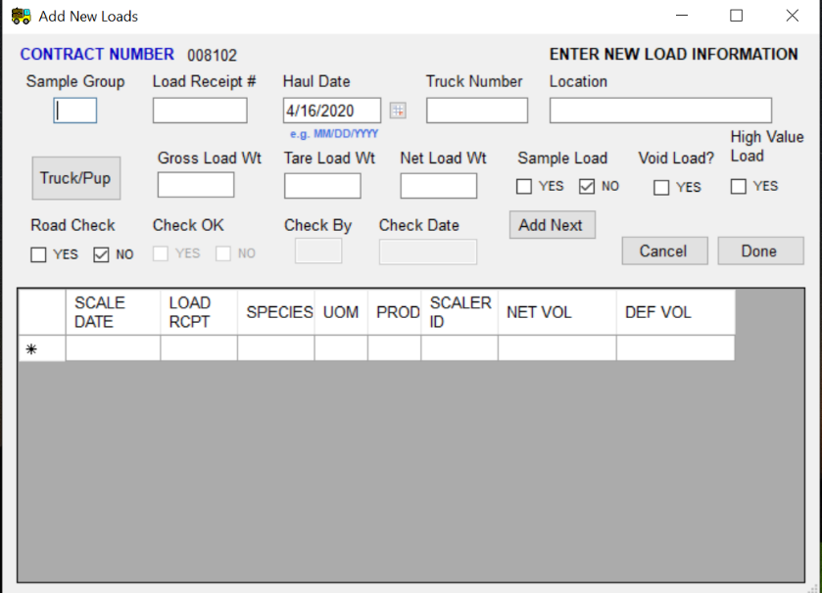

The form is divided into two sections, load information at the top and sample load information at the bottom. Some automatic completion is provided in this form and is discussed in the field descriptions below. The **TAB** and **SHIFT TAB** keys are used to move between fields. Continue adding records by clicking the **Add Next** button. This increments the log load receipt number and repeats the sample group, date, truck number and location and puts the cursor in the **Gross Load Wt.** box.

***Contract number –*** This is the number assigned to sale. It is automatically provided on this form and cannot be changed.

***Sample Group and Load Receipt #*** -- The sample group is entered by the user. When the user leaves the sample group field, the program finds the last log load receipt entered for this sample group and increments it for the next number. The user has the option to change this number by double clicking the number and typing in a new number. The program also checks to ensure the receipt number is not outside the range of tickets for the associated book number. If the ticket number is outside the range for the book, the log load receipt number is set to blank allowing the user to enter the next valid log load receipt. If sample group was previously entered as blank, it must be entered here as blank (must be one space and not just empty).

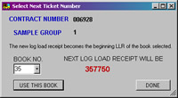

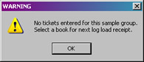If no tickets have been entered for this sample group yet, the user can select a book from the list provided. The next available ticket number is shown and clicking **Done** selects the ticket number and puts it in the Load Receipt # box.

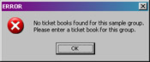

Additionally, if no ticket books were entered for the sample group, a warning is displayed and the user is required to enter ticket books before continung.

***Haul Date –*** The date the load was brought to the mill. This is a required field and must have a four digit year. The default is the current date when the program is run and may be changed by the user. Alternatively, clicking the calendar button opens the current month where the user can click the haul date which automatically fills the haul date.

***Truck Number –*** The number assigned to the truck. This number is optional and used only for reporting purposes.

***Location –*** The location where the load was presented for scale. If this field was completed when Sample Groups were set up, it automatically populates in this form.

***Gross Load Wt –*** The gross load weight for the load. It is optional.

***Tare Load Wt –*** The tare load weight or weight of the empty truck. It is optional.

***Net Load Wt –*** Net load weight for the load. If load weight is being used in the first stage sample expansion then it is a required field. If left blank, the program computes the value by subtracting the Tare Load Wt from the Gross Load Wt. If gross and tare are left blank, the user may enter the Net Load Wt.

***Sample Load –*** Default is **No**. By clicking **Yes**, the user indicates sample loads are to be entered for this load. When this is clicked, the haul date and log load receipt number populate the first line in the bottom of the form as **Scale Date** and **Load Rcpt**. Scale Date may be changed but Load Rcpt cannot and is actually set to a Read Only property. Details of the **Sample Load Information** area are given below.

***Void Load –*** By clicking **Yes**, the user indicates to the program this load is voided. A “**V**” is placed in the missing load field within the database and is displayed in reports showing the missing load field.

***Road Check –*** Optional field. Determines whether a Road Check was done on this load. The default is **No**.

***Check OK –*** If **Yes** was checked for Road Check, this field is available for clicking **Yes** (road check was OK) or **No** (road check failed).

***Check By –*** If **Yes** was checked for Road Check, this field is available for entering the ID of the person who did the road check.

***Check Date –*** If **Yes** was checked for Road Check, this field is available for entering the date of the road check.

***High Value Load*** – Check **Yes** if this load is considered a high value load.

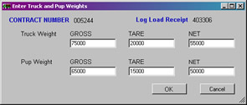***Truck and Pup Button –*** This is a special feature on the **Add New Loads** form. If the load had a truck and pup component, click this button to enter the weights for each. When this button is clicked, the **Enter Truck and Pup Weights** window is displayed. The **Contract Number** and **Log Load Receipt** number are displayed at the top and cannot be changed. Enter the gross and tare weights for the truck and pup separately. The program calculates the net weight and displays it in the appropriate box. When the **OK** button is clicked, the program adds the weights together and displays the values in the weight fields in the top of the **Add New Loads** form.

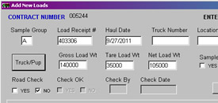***Sample Load Information –*** When **Yes** is checked for **Sample Load**, the program checks Scale Method for the current contract and displays the appropriate fields for either *3P* or *Conventional Scale* as needed (see below). **Scale Date** and **Load Rcpt** are automatically completed from the information entered in the top portion of the window. Scale Date may be changed by the user but Load Rcpt is marked as Read Only and cannot be changed. Enter one line for each unique Species, Product and Unit of Measure and complete the remaining fields on the line as needed. Use the **TAB** or **SHIFT TAB** keys to move between fields on the line.

***Weight Scale –*** In order for species and product codes to be entered in the TSA file, one sample load must be entered into the contract. Under the column **NET VOL**, enter the percent of the load to be counted as this species/product. For example, a single species load would have 100 entered in this column to denote 100% of the volume is to be placed in this species. The percent could also be in terms of the load weight. If the net load weight was 50,000 pounds, enter 50000 in the NET VOL column. If multiple species are present, the percent may be split among the species. For example, two species comprise the load with one species to represent 60% of the volume and the other 40% of the volume (these percents should be available from the reports). Enter 60 for one species and 40 for the other into the NET VOL 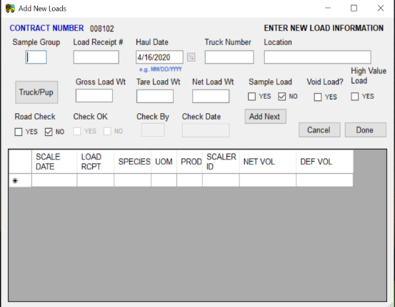column. Alternatively, enter the load weight for each as 30000 (50,000 * .60 = 30,000) and 20000 (50,000 * .40 = 20,000) in the NET VOL column.

The fields displayed for **Sample Load Information** depend on the Scale Method. Field definitions are below these examples. Here’s an example of what is displayed for Conventional, Weight and Load Count methods.

Here is an example of what is displayed for 3P method. Notice this window has been expanded to show all of the fields for Sample Load Information. This is done by clicking the lower right corner of the window with the mouse and dragging the corner to expand the window.

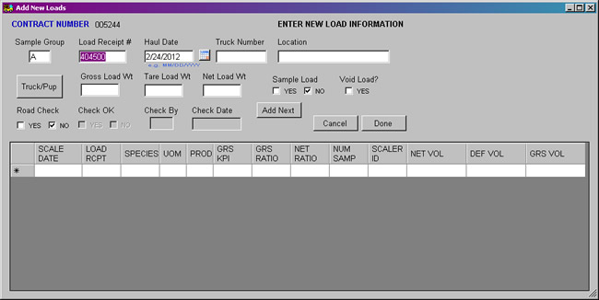

Listed below are descriptions for any field to be displayed.

***Scale Date –*** The date the load was scaled. This is a required field and must have a four digit year. It is copied from the haul date at the top but may be changed by the user.

***Load Rcpt –*** Load receipt number. Must be unique. Load receipt number is copied from the information at the top and is a Read Only field for Sample Load Information.

***Species –*** Species code may be up to six characters in length. It must match the species code defined in the Contract Species table.

***UOM –*** Two digit Unit of Measure code. 01 is Board Foot, 03 is Cubic Foot and 05 is Tons.

***Prod –*** Two digit Product code. If one digit is entered, a preceding zero is added when the data is saved.

***Grs KPI –*** Sum of the gross KPIs for each species, product and UOM combination for the load.

***Grs Ratio –*** The total ratio between the sum of the predicted volumes and the sum of the scaled gross volumes for each species, product and UOM combination for the load. If no scaled volumes were taken, the Gross Ratio should equal zero.

***Net Ratio –*** The total ratio between the sum of the predicted volumes and the sum of the scaled net volumes for each species, product and UOM combination for the load. If no scaled volumes were taken, the Net Ratio should equal zero.

***Num Samp –*** Number of logs which were scaled for each species, product and UOM combination for the load.

***Scaler ID –*** The ID for the scaler who scaled the load.

***Net Vol –*** Sum of the net sure-to-meaure volume (if any) for each species, product and UOM combination for the load.

***Def Vol –*** Sum of the defect sure-to-measure volume (if any) for each species, product and UOM combination for the load.

***Grs Vol –*** Sum of the gross sure-to-measure volume (if any) for each species, product and UOM combination for the load.

If the scale method is **LOAD COUNT**, the following window is displayed.

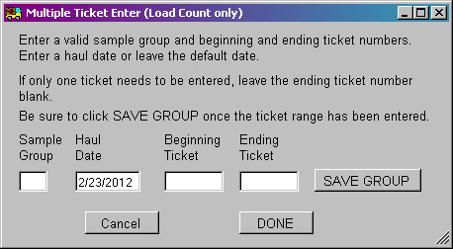

When entering new loads under the Load Count method, a range of tickets may be entered for a sample group and the program populates the All Loads table with a line for each ticket number in the range. Simply enter the sample group and the beginning and ending ticket number. The haul date defaults to the current date but may be changed by the user.

Sample group is checked to ensure it is a valid code and the ticket numbers are confirmed as valid for that sample group.

When **Save Group** is clicked, the program enters each ticket with the haul date and the sample group entered. A blank sample group is allowed but must be a single space and not just empty.

A message indicating all tickets were entered is displayed. The program does check to ensure duplicate tickets are not being entered. Since the range could span 50 tickets or more, the warning simply indicates a number of duplicate tickets were found and duplicates were not entered.

Click **DONE** when finished entering ticket ranges.

**Warning symbolNOTE: Clicking the X button in the upper right corner also closes the window. However, no confirmation window is displayed and no data entered is saved.**

**Warning symbolNOTE: When exiting the Add New Loads window, the program checks for any missing data on sample loads. A warning message is displayed. If data was inadvertently missed, this allows the user to edit the data and enter the missing sample load information.**

**Warning symbolNOTE: Known issue – Ticket number is accidently used for the wrong sample group. For example, ticket number from book assigned to Sample Group A accidently used for Sample Group B. Change the Ticket Book receipt numbers to remove those receipt numbers and add a new ticket book number assigned to the correct sample group with those receipt numbers.**

**Example:**

**Ticket Book 151; Sample Group A; Receipt Numbers 1501 to 1519**

**Ticket Book 151A; Sample Group A; Receipt Numbers 1521 to 1559**

**Ticket Book 151B; Sample Group B; Receipt Numbers 1520 to 1521**

# EDITING SCALED/UNSCALED LOADS

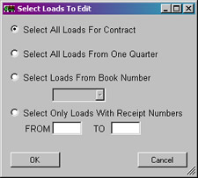

*Click one of the four options and enter any extra information required; i.e. book number.*

*When an option has been selected, click* ***OK*** *to go to the next window.*

*Enter a log load receipt and click* ***Find Load*** *to go to that record.*

*Click this button to* ***save*** *the data.*

*Click this button to* ***delete*** *a load.*

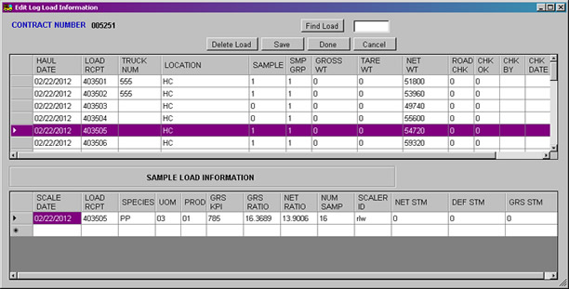

*Click this button to* ***close the window and save the data****.*

*All log load receipts are displayed here.*

*Click this button to close the window.*

*If a load shows* ***samples*** *were collected, the sample loads are shown here.*

The **Edit Log Load Information** window allows the user to edit and review log load receipts to the contract. From the **Main Menu**, select *Data* from the toolbar and then select *Edit Load(s)*. The first window (shown at the top) lets the user select specific loads from a quarter, a book, a range of log load receipt numbers or simply all loads for the currently open contract. Once the first window is complete and the **OK** button clicked, the **Edit Log Load Information** window opens. See **Appendix B** for selecting quarterly dates.

There are no specific steps to follow for this particular window so a general description of what these windows can do is provided.

***Editing Log Load Data***

Similar to other grid displays, the user may edit any cell in the form. Simply click on the desired cell and enter the new information. Edits are saved using the **Save** or **Done** buttons.

If the load is a truck/pup load, clicking anywhere on that row asks if the weights are to be changed. Clicking **Yes**, displays the **truck/pup** window where the weights can be modified. Clicking **OK** in that window closes the window, updates the weights and allows other fields to be edited. Clicking **No** in the initial display allows other fields to be edited.

***Review and Edit Sample Load Information***

In the top box, the column marked **SAMPLE** indicates whether sample loads were collected for the log load receipt listed. A “0” means no sample loads exist for the load while a “1” means at least one sample load was collected. To see the sample loads, click on the log load receipt number (or row) and the sample loads appear in the bottom box.

Sample load information is edited in the same way as log load data at the top. Simply click on the cell to change and enter the new information. Edits may be saved using the **Save** or **Done** buttons.

***Find Load Button***

Usually, the list of log loads is longer than the grid so most of the loads are not visible in the grid form. So if the user wants to edit a particular log load, they would have to scroll through the list to find it. The **Find Load** button facilitates a quick search for the log load receipt number. Simply enter the log load receipt number in the box and click the **Find Load** button. The found row is highlighted.

***Delete Load Button***

When this button is clicked, the load highlighted (or clicked) and all associated sample loads are deleted from the form as well as from the database.

***Save and Done Buttons***

There is a distinction between these two buttons. The **Save** button saves all the updated data and leaves the window open. The **Done** button saves the data but closes the window.

***Cancel Button***

******As with most of the windows in the program, the **Cancel** button confirms the user really wants to close the window without saving any data. If no changes were made, click **YES** to close the window. If Cancel was accidently clicked and changes were made and need to be saved, click **NO**.

**Warning symbolNOTE: Clicking the X button in the upper right corner also closes the window. However, no confirmation window is displayed and no data entered is saved.**

# SCANNING LOADS

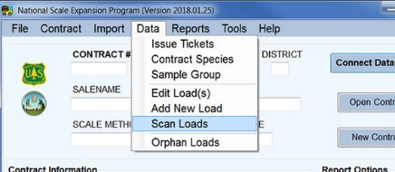A new feature (2018) was added to the program which allows the user to scan the bar code on a log load receipt. It works with any bar code scanner having a USB port connection. Follow the steps below to use this new feature.

1. Connect the bar code scanner to a USB port. It beeps to indicate it is ready to scan.
2. 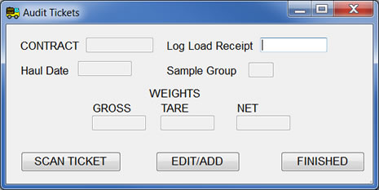On the Main Menu toolbar, click on **Data** and then on **Scan Loads**. A contract does **NOT** need to be open to do this.
3. On the Audit Tickets window, only the log load receipt can be edited but this is not necessary. Click on the **Scan Ticket** button. Using the bar code scanner, scan the bar code on the ticket.
4. 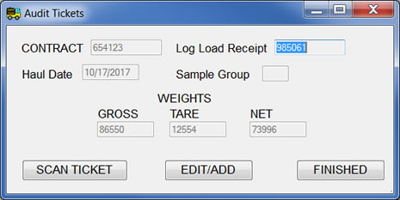The program then checks the database for the ticket number. One of two things can happen at this point.
   1. The ticket was found in the database so the associated information is displayed in the Audit Tickets window. If any of the information is incorrect, click the **Edit/Add** button to correct the data. If the data is correct, click the **Scan Ticket** button to scan the next log load receipt.
   2. 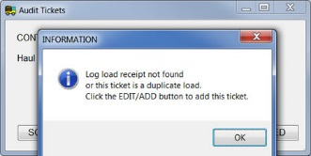If the ticket was not found, the user has the option to enter the load.
      1. Click the **Edit/Add** button and a window opens where associated information such as the weights can be entered.
      2. 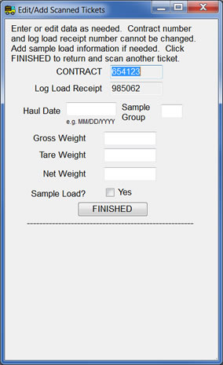If the load is a sample load, check the **Sample Load? Yes** box. In the space at the bottom, associated sample load information is entered.
      3. If the program determines the sale is a 3P method, fields to enter that information also appear in the space at the bottom.
   3. Continue scanning tickets by clicking the **Scan Ticket** button and scanning the bar code.
   4. When all log load receipts have been scanned, click **Finished** to close the window.

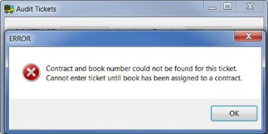

If the program determines there is no book or contract for the load scanned, a warning message is displayed and the load is not added to the database.

This features works best when log load receipt information is either imported or entered prior to scanning the ticket. Usually, loads imported are in the database so this feature becomes an audit check on the data imported. As mentioned above, if the ticket is not found, there is the option to add the load to the database.

# ORPHAN LOADS

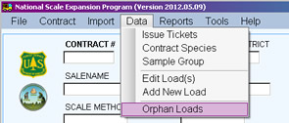When a file is imported, there is a possibility the loads do not have an associated contract entered in the database. These loads are either deleted or modified to be associated with a current contract in the database or otherwise modified for use. To manage orphan loads, click on *Data* in the menu at the top and then select *Orphan Loads*.

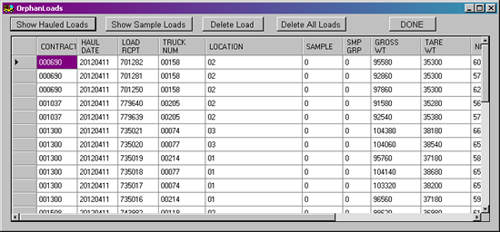

This displays the Orphan Loads window where the user edits the load record as needed or may delete the record completely. Initially, all orphan hauled loads are displayed. Orphan sample loads may be selected by clicking the **Show Sample Loads** button. If there are no orphan sample loads, a warning message is displayed and the hauled loads remain in the window.

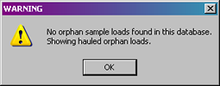

To delete a single load, highlight the row to delete and click the **Delete Load** button. The record is removed from the window as well as from the database.

Alternatively, all of the loads may be deleted by clicking the **Delete All Loads** button.

To edit a particular field, simply click on the field and enter the correct data. When finished with edits and deletions, click the **DONE** button. All edits are saved to the database and the window is closed.

# REPORTS

***Reports*** *are also accessible from the toolbar.*



***Report Options section***

There are six categories of reports: *Summary Reports*, *Audit Reports*, *Periodic Volume Calculation*, *Quarterly Volume Summary*, *Missing Load Report*, and *Frequency Reports*. Reports can be selected from the **Report Options** section by clicking the button for the desired category. Alternatively, the categories can be accessed by selecting *Reports* from the toolbar and then selecting the desired category. Each category is described below. Examples of each report are shown in ***Appendix A***.

For most reports, the user can select a range of dates to use in the report. This usually covers a month or a quarter for a particular fiscal year. A special window for setting dates is displayed when dates are required. A detailed description of this window is covered in ***Appendix B***.

Reports are generated using a single filename. Depending on the report, the contract number may be included in the filename. All report filenames have an extension of .TXT and are updated every time the report is generated. A table of filenames for each category is shown in ***Appendix A***.

## Summary Reports

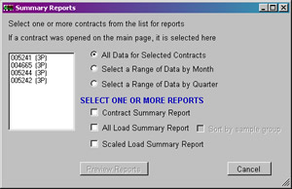

*Select* ***range of dates*** *to include in the report.*

***Cancel*** *button closes window*

***Preview*** *button*

***Reports*** *available in this category*

***Contracts*** *available*

The **Summary Reports** category offers three reports summarizing contract data. Click **Summary Reports** on the Main Menu to open this window. Alternatively, select *Reports* from the toolbar and then *Summary Reports*.

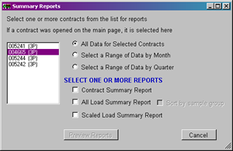The **Contracts List** box on the left shows all contracts available for report generation. If no contract is open on the Main Menu, the list appears as above. If a contract is open, the list appears as in the example at right with the currently open contract highlighted. The user can select other contracts for the report by clicking and highlighting the contract number in the list. Conversely, the contract may be removed from inclusion by clicking it again. All contracts may be selected by holding down the shift key and click on the first and last contract.

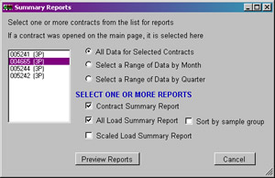At this point, the **Preview Reports** button is not available. This indicates additional action is required. First, select a range of dates to include in the report from the list in the upper portion of the window by clicking the button. Data from a quarter or a month can be included in the report or all data, regardless of date, can be included. Next, one or more reports from the bottom portion of the window need to be selected. Once one report is checked, the **Preview Reports** button becomes available.

***Contract Summary Report***

The Contract Summary report displays information about each selected contract. Contract setup, tickets issued, contract species and sample groups are summarized and displayed in tables.

***All Load Summary Report***

This report displays the load information, sorted by load receipt number. The load counts and load weights are summed by sample loads, nonsample loads and total loads. Monthly totals are produced as well as an overall total. There is the option to sort the data by sample groups and then by load receipt number

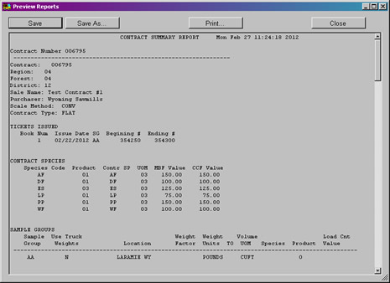

***Scaled Load Summary Report***

This report sums the sample load information sorted by sample group, unit of measure, product and species. Overall totals are produced for each sample group/unit of measure combination.

Click the **Preview Reports** button to open the review window. Drag the lower right corner with the mouse to resize the window.

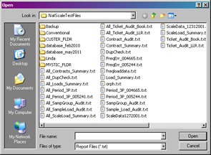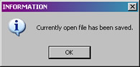The first report selected is displayed. At this point, four options are available. The currently open report can be saved by clicking the **Save** button. A message indicating the file was saved is shown and is closed by clicking **OK**.

To save the report using a different filename, click the **Save As** button. This opens the standard browse window where the user can select a filename or enter a new filename.

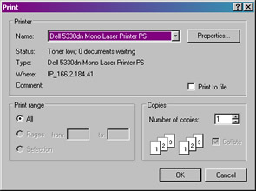

The **Print** button does just that. It prints the report to the printer selected from the standard print window.

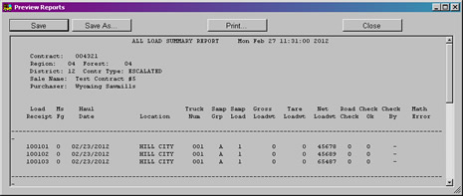

When the **Close** button is clicked and multiple reports were selected, the next report is displayed in the preview window. The user can again save the file, save with a different filename, print the report, or close the window. If no more reports were selected, the **Close** button closes the preview window.

**Warning symbolThe Save and Save As buttons both save the text file in RTF format. When viewed in a text editor, the formatting symbols show whereas if opened with Microsoft Word, the formatting is hidden and the file opens cleanly. When the Preview Window is closed, the file is automatically saved as a plain text file and opens cleanly in a text editor.**

## Audit Reports selection windowAudit Reports

*Select* ***range of dates*** *to include in the report.*

***Reports*** *available in this category*

***Preview*** *button*

***Contracts*** *available*

***Cancel*** *button closes window*

**Audit Reports** are primarily used to check for missing loads or load receipts hauled out of order. Click the **Audit Reports** button on the Main Menu to open this window. Alternatively, select *Reports* from the toolbar and then *Audit Reports*.

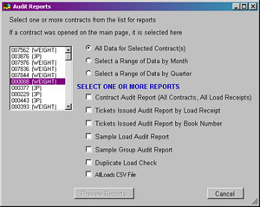The Contracts List box on the left shows all contracts available for the reports. If no contract was opened on the Main Menu, the list looks like the example above. If a contract is open, the list appears as in the example at right with the currently open contract highlighted. The user can select other contracts for the report by clicking the contract number in the list. Conversely, the contract may be removed from inclusion by clicking it again. To select all contracts simply hold down the shift key and click on the first and last contract numbers.

Initially, the **Preview Reports** button is not available. A range of data and the desired reports need to be selected before the reports can be viewed. The range of data is selected by clicking the appropriate button in the upper portion of the window. Range of data may include all data for the contracts selected regardless of date, or all data for a particular month or a particular quarter. Next, one or more reports from the bottom portion of the window can be selected. Once one report is checked, the **Preview Reports** button becomes available.

***Contract Audit Report***

This report creates a list of all the contracts in the database and counts the number of hauled loads and the number of sample loads. The report also prints any load which has not been setup. These loads are referred to as Orphaned Loads. If they have been loaded into the database by accident, they need to be removed and mailed to the correct person for importing into the correct database.

***Tickets Issued Audit Report***

This report can be generated by *Log Load Receipt* or by *Book Number*. Tickets Issued Audit Report by Load Receipt prints a table showing the load receipt numbers issued versus the load receipt numbers hauled. Missing loads show up as blank lines. Loads hauled before they have been issued show up as blank lines. The data is sorted by log load receipt number.

Tickets Issue Audit Report by Book Number is the same as by log load receipt only it is sorted by book number.

This report can also be used to audit sample groups. If the Use Wts column has a ‘Y’ recorded then the net load weight column must contain a weight. If the Use Wts column has an ‘N’ recorded, it does not matter if the net load weight column has a value or not.

***Sample Load Audit Report***

This report shows all the hauled loads declared as sample loads with the corresponding sample load information. If a hauled load is declared a sample load and there is no corresponding sample load, the sample load side of the table shows a blank line. If there is a sample load with no hauled load, the hauled load side of the table shows a blank line.

***Sample Group Audit Report***

The Sample Group Audit report attempts to match the sample groups defined in the Sample Group table with sample groups used in the All Load table. If the sample groups exist in both the All Load and Sample Group tables, a count of the number of hauled loads is computed for that sample group. If an undefined sample group exists in the All Load table, a ‘—‘character shows up in the sample group column of the Sample Group table. Sample groups must match exactly between the Sample Load table and the All Load table for the data to be expanded correctly.

***Duplicate Load Check***

The duplicate load check looks for two or more loads with the same log load receipt number.

**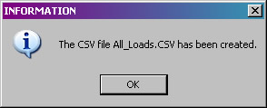*AllLoads CSV File***

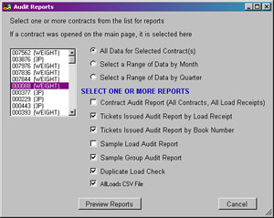Often, there is a need to have the AllLoads table in comma-delimited form (CSV) for additional checking in an Excel spreadsheet. This report creates a CSV file containing contract number, haul date, log load receipt number, truck number, location and gross weight. It can include all contracts or a single contract. It can also include a single month or whatever time period was selected. A message is displayed when the file is completed.

A completed selection for **Audit Reports** is shown at left.

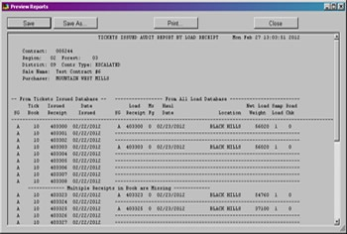Click the **Preview Reports** button to open the review window. All reports selected have been created at this point. The window can be resized by dragging the lower right corner. Four buttons at the top offer some options for the report.



The open report can be saved by clicking the **Save** button. This saves the report using the original filename. A message indicating the file was saved is shown and is closed by clicking **OK**.

To save the report using a different filename, click the **Save As** button. This opens the standard browse window where the user can select an existing filename or enter a new filename. It can also be used to locate a different directory for saving the file.



The **Print** button sends the open report to the printer selected from the standard print window.

When the **Close** button is clicked and multiple reports were selected, the next report is displayed in the preview window. The user has the option to save the report, save it with a different filename, or print it. For multiple reports, each time the **Close** button is clicked, the next report is displayed. When all reports have been shown, clicking the **Close** button closes the window.

**Warning symbolThe Save and Save As buttons both save the text file in RTF format. When viewed in a text editor, the formatting symbols show whereas if opened with Microsoft Word, the formatting is hidden and the file opens cleanly. When the Preview Window is closed, the file is automatically saved as a plain text file and opens cleanly in a text editor.**

## Periodic Volume Report

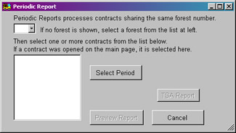

*Select a* ***forest***

***Contracts*** *available*

***Create TSA file*** *with this button*

*Select* ***time period*** *for the report*

***Cancel*** *button closes window*

***Preview*** *button*

The **Periodic Volume Calculation** report does all the sample volume expansions and produces a report of those volumes. The volume is expanded based on the combination of two factors: the type of sale (flat rate or escalated) and the scale method (3P, Conventional, Weight or Load Count). The periodic volume report produces a table with all of the elements necessary to hand calculate the volumes. For 3P scale, a walkthrough of the calculations is also provided. The volumes displayed are either the contract-to-date volume if the sale is a flat rate sale or the quarter-to-date volume if the sale an escalated sale.

This report creates one file for each contract selected. Click the **Periodic Volume Calc** button on the Main Menu to open this window. Alternatively, select *Reports* from the toolbar and then *Periodic Volume Calc/TSA*.

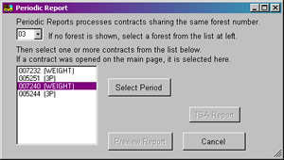The items needed in this window are slightly different from other reports. The first box is a list of available forests. Notice the statement at the top of the window. Only contracts with the same forest number are processed in this report. If only one forest is available for all contracts available in the database, the forest is displayed in this window and the contracts list box is filled. Another option is when a contract is opened on the Main Menu. The associated forest is displayed along with the currently open contract highlighted in the contracts list box as shown in the example at right.

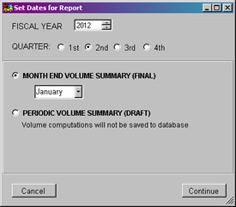

The report cannot be generated until a period of time is selected. Notice the **Preview Report** button is disabled initially. Click the **Select Period** button to open the *Set Dates for Report* window (Detailed in ***Appendix B***.) Select the fiscal year and quarter for the report. Additionally, the draft or final report for the window is selected here. Click the **Continue** button to close the window.

*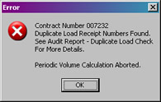Pencil symbolNOTE: When the draft version of this report is selected, no volume calculations are saved in the database. This impacts quarterly reports in that no data is available to generate that report. It is necessary to select final report for the Periodic Volume report in order to get the quarterly report.*

*Warning symbolIf duplicate log load receipts are found, the report is not created until the issue is resolved.*

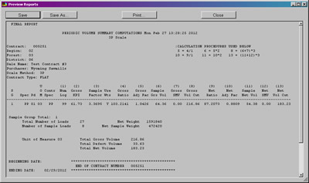Once the period is selected, the **Preview Report** button becomes available. Click this button to open the review window. The window can be resized by dragging the lower right corner.

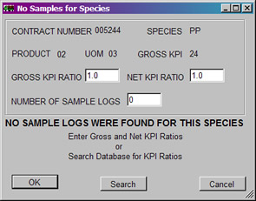

When a 3P scale method has a species, product and unit of measure group with no measured logs, a warning screen is displayed and the user is prompted to add a gross and net ratio for the sample. If a ratio of zero is entered, no volumes are computed for that group. If a ratio of 1 is entered, the sum of the KPIs is used as the volume for that group. The number of sample logs should be kept at zero for tracking purposes. Click **OK** when the information needed is complete.

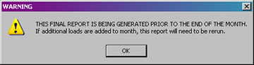If the user is running the month end report in the middle of the month, a warning message is displayed. For example, running the February month end report on February 27, 2012 would cause the following message to be displayed. It is merely a warning and the message is closed by clicking the **OK** button. However, if the volume is reported to TSA and additional loads are hauled for the month, the report needs to be rerun and the difference in volume between the two runs needs to be reported to TSA.

See ***Appendix A*** for an example of this report and what data is included.

Four options are available on the review window. First, the report can be saved by clicking the **Save** button. A message is displayed indicating the file was saved and is closed by clicking **OK**.



To save the report using a different filename, click the **Save As** button. The standard browse window is opened so the user can select an existing filename or type in a new filename or navigate to a different folder to save the file.



To print the report, click the **Print** button. The standard print window is displayed allowing the user to pick a printer.

**Warning symbolThe Save and Save As buttons both save the text file in RTF format. When viewed in a text editor, the formatting symbols show whereas if opened with Microsoft Word, the formatting is hidden and the file opens cleanly. When the Preview Window is closed, the file is automatically saved as a plain text file and opens cleanly in a text editor.**

Since only one report for periodic volume is generated, when the **Close** button is clicked, the window actually closes. The program returns to the Periodic Volume window where the **TSA Report** button is now available.

**TSA Report**

Clicking this button creates a text file which can be used to send the Periodic Volume data to TSA. The transaction file can only be created when Month End Volume Summary is selected for the range of data. When complete, this message is displayed showing the file was created and the path where the file is stored. Clicking **OK** closes the message.

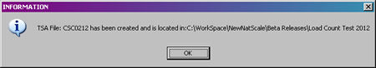

The **Cancel** button returns the user to the Main Menu.

Warning symbol***IMPORTANT NOTE: Do NOT edit the TSA file with a Windows or DOS based editor. The TSA file is in a UNIX format and needs to remain in that format for TSA to import the file correctly.***

An example of the TSA file is shown below. The file is named with “CSC” and the month and year requested. For example, the example shown here is from a file called “CSC0712” which represents volume for July 2012.

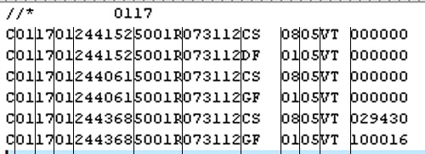

When multiple contracts are selected for this report, the TSA file does contain records for each species/product combination in each contract. This example contains records for three contracts for the month of July in 2012. Two of the contracts did not have volume in July so the period volume shows zero. Lines have been added to show each column in the file. These lines do not appear in the file to be transmitted.

The first column of the file contains special characters followed by the region and forest (0117). Subsequent columns contain:

* Character “C”
* Region
* Forest
* District
* Contract number
* Constant (5001R)
* Last date of the period (073112)
* Species (CS, DF, GF)
* Product (08, 01)
* Unit of Measure (05)
* Constant (VT)
* Net volume for the period

## Quarterly Summary Report

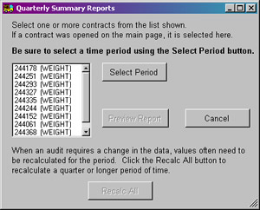

*Select* ***time period*** *for the report*

***Contracts*** *available*

***Cancel*** *button closes window*

***Recalc All*** *button*

***Preview*** *Report button*

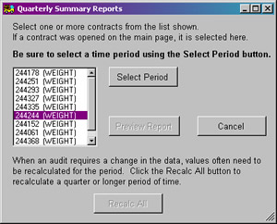The Quarterly Summary Report of Volume Statement of Account computes the monthly cut volumes the purchaser is charged against. There are three pages to the report: Monthly Cut Totals, Contract-to-Date or Quarter-to-Date summaries by sample group, and Contract-to-Date or Quarter-to-Date summaries.

The **Quarterly Summary Report** is similar to the Periodic Volume Report in that it produces only one file per contract. Click the **Quarterly Summary** button on the Main Menu to open this window. Alternatively, select *Reports* from the toolbar and then *Quarterly/Statement of Account*.

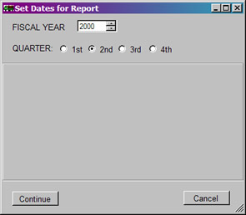The **Contracts List** box on the left shows all available contracts for this report. If no contract was opened on the Main Menu, the list appears as above. If a contract was opened, the list appears as in the example at right with the currently open contract highlighted. The user can select other contracts for the report by clicking to highlight the contract number in the list. Conversely, the contract may be removed from inclusion by clicking it again. All contracts can be included by holding down the shift key and clicking on the first and last contract in the list.

Initially, the **Preview Report** button is not available. A range of dates to include in the report must be selected first. Select the fiscal year and quarter to include from the *Set Dates for Report* window (see ***Appendix B***).

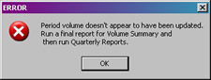Warning symbol*If the draft report for the Volume Summary report was generated instead of the final report, no data is available for quarterly reports. An error message is displayed as shown here.*

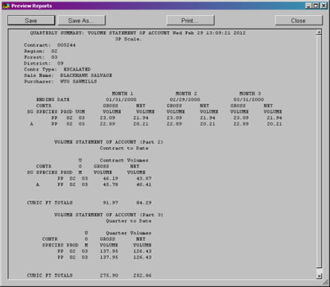

Once the period is selected, the **Preview Report** button becomes available. Click this button to open the review window. The window can be resized by dragging the lower right corner.

See ***Appendix A*** for an example of this report and what is included.

***Monthly Cut Totals***

The first page of the report shows the monthly cut volumes by sample group, species, product and unit of measure. If the sale is an escalated sale, the report shows the cut volume for each of three months in the quarter as they are computed. If the sale is a flat rate sale, the cut volume for each month is displayed by fiscal year and quarter for the life of the sale. The monthly cut total is computed by calculating either the Quarter-to-Date or Contract-to-Date volume and subtracting off the previous month’s Quarter-to-Date or Contract-to-Date volume. If volume is being computed for the first month of a quarter and the sale is an escalated sale, the Quarter-to-Date volume and monthly cut volume are the same.

***Contract-to-Date or Quarter-to-Date Summary by Sample Group***

The second page of the report displays the sum of the monthly volumes by sample group, species, product, and unit of measure. If the sale is an escalated sale, this is the Quarter-to-Date summary. If the sale is a flat rate sale, the volume displayed is the Contract-to-Date summary.

***Contract-to-Date or Quarter-to-Date Summary***

The third page of the report shows the same volumes as page two except the volume summaries are by species, product and unit of measure. If there are no sample groups in the sale, page two and page three show the same numbers. This first page under the current month’s heading represents the data as it appears in the TSA file.

The review window has the same four options as other review windows. First, the report can be saved by clicking the **Save** button. A message is displayed indicating the file was saved and is closed by clicking **OK**.

To save the report using a different filename, click the **Save As** button. The standard browse window is opened so the user can select an existing filename or type in a new filename or navigate to a different folder to save the file.

To print the report, click the **Print** button. The standard print window is displayed allowing the user to pick a printer.

**Warning symbolThe Save and Save As buttons both save the text file in RTF format. When viewed in a text editor, the formatting symbols show whereas if opened with Microsoft Word, the formatting is hidden and the file opens cleanly. When the Preview Window is closed, the file is automatically saved as a plain text file and opens cleanly in a text editor.**

Since only one report for the quarterly summary is generated, when the **Close** button is clicked, the window actually closes.

*Pencil symbolNOTE: This report is actually titled “QUARTERLY SUMMARY: VOLUME STATEMENT OF ACCOUNT” and the filename is Volume_Statement.txt*

***Recalc All Button***

Initially, this button is not available. Once the time period is selected, it becomes available. Occasionally, there may be missing months in the calculated data. The Recalc All function can remedy this situation by calculating the missing periods for data entered. This could be data for an entire month which was never entered. Or, it could be a few records in a period which has already been calculated. If the sale type is escalated, only data for the quarter selected is recalculated. If the sale type is flat, data for the life of the contract is recalculated.

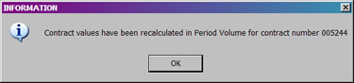When the recalculation is complete, the message shown here is displayed. Click **OK** to close the window.

## Missing Load Logic

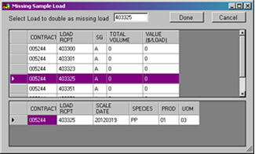

Missing load logic is based on the national directives for dealing with missing log loads. If the Tickets Issued or Sample Load Audit reports show that a load is missing, the program provides all the information necessary to replace a missing load. There are three types of loads which can be missing: Hauled Load, Hauled Load for a weight scale, or a Sample Load.

***Hauled Load***

If the loads are not being weighed and the load was a nonsample load, just add the load to the database. If the loads are being weighed then add the missing load using the average net weight for all loads hauled in the quarter. The All Load Summary Report lists the number of loads hauled in a quarter and the total net weight for those loads. Simply divide the total load weight by the number of loads to find the average load weight.

***Hauled Load for a Weight Scale***

If the scale is a true weight scale (all the loads are weighed and a weight factor is used to produce volumes) then the missing load is equal to the heaviest load hauled for the quarter. The All Load Summary Report lists all the net weights for all the loads hauled in the quarter. Find the largest net weight and use that weight when adding the missing load.

***Sample Load***

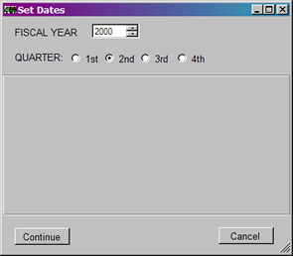For a missing sample load, the directive is to take the highest value sample load for the quarter (escalated) or for the sale to date (flat rate) and duplicate the load in place of the missing sample load. The program finds the value for each sample load using the species values in the Contract Species table. To find the value of each load, select Missing Load Logic by clicking the button at lower right on the Main Menu. Alternatively, select *Reports* on the toolbar and then *Missing Load Logic*.

The first window displayed is the *Set Dates for Report* (see ***Appendix B***). Select the fiscal year and quarter to use in the report. Click **Continue** to close the window.

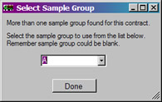If more than one sample group is defined for the contract, the **Select Sample Group** window asks the user to select the correct sample group from a pulldown list. For each sample load, the total volume and total value is displayed. If sample weights are used, the value is expressed in terms of dollars per 1000 pounds ($/M lbs). If sample weights are not used, the value is expressed in dollars per load ($/load).

Clicking on a load displays the species information in the lower table. Select the load with the highest value and click **OK**. The missing load is filled in using the selected load information. A star or asterisk (*) is added to the **Missing Load** column for the load receipt number to identify it in the future as a duplicated high value load.

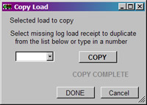

Clicking the **Done** button displays the window at left. This window allows the user to select the missing log load receipt and copy the information selected from the window above to the database. Click the **COPY** button to start the process. When finished, “COPY COMPLETE” is highlighted. Click **DONE** or **CANCEL** to close the window.

## Frequency Calculation Report

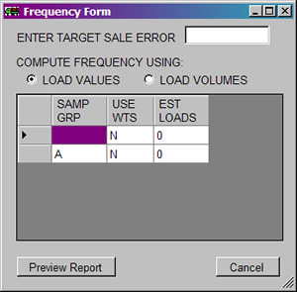

The **Frequency Report** produces a table containing the computed first stage frequency for each sample group in the contract and the statistics used to compute this number.

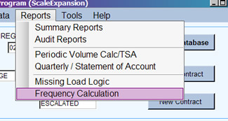The **Frequency Calculation** is only available from the toolbar on the Main Menu. Select *Reports* and then *Frequency Calculation* to open this window. Only one report per contract is generated from this window.

Click the **Preview Report** button to review in the preview window as with other reports. See an example of this report in ***Appendix A.***

***Enter Target Sale Error***

This is the final sale error the contract is trying to meet. The error should already be defined in the contract so refer to the contract specifications before setting this value.

***Compute Frequency***

Two options are available to determine the sampling frequency:

**Load Values –** Using sample load information, the total value for each truck is computed by multiplying the volume per species and product by the value entered in the contract species table. These total values by truck are used to compute the average value per truck, the standard deviation, CV and sampling frequency.

This option is required if there are more than one unit of measure per truck. For example, sawtimber in board feet and pulpwood in cubic feet mixed on the same trucks. These two volumes cannot be added together to produce a single total volume per truck.

**Load Volumes –** Using sample load information, the total volume for each truck is computed by summing the volume for each species and product. These total volumes by truck are used to compute the average volume per truck, the standard deviation, CV and sampling frequency.

*Pencil symbolNOTE: When using a 3P scale method, the 3P sample expansions are computed using all of the sample loads and then these expansions are applied back to each truck’s KPI values accordingly.*

***Sample Group Table***

For each displayed sample group, an estimate of the total number of loads expected to be hauled is required.

When the Frequency form is complete, clicking the **OK** button generates the report. The report consists of two tables. The first table displays a list of species and products with either the computed adjustment factors for 3P scale or the total volume for conventional scale. The recorded value for each species and product is also listed.

The second table contains all of the statistics necessary to compute the frequency. The statistics are either in value, volumes or volume/weight depending on the information provided in the Frequency form.

# IMPORT FILES

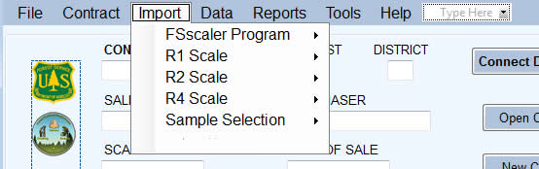

*Five options to select from*

*Access through the toolbar*

Importing data is one method of adding new load information. Several import routines are available in the ScaleExpansion program: the FSscaler Program, the Region 1 Idaho Panhandle data, the Region 2 Neiman data collection program, the log scale data collection program provided by Electronic Data Solutions, and the Sample Selection process.

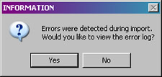

When data is imported, if data already exists for a log load receipt, the program produces an error statement, skips the load, and continues with the import. After the import, the program indicates whether any errors occurred during the import and gives the option to view the error file.

*Pencil symbolNOTE: Scalers should ensure they use the same exact contract number in the data recorder as what the resource clerk has set up for a specific contract in ScaleExpansion. This ensures a smooth import of the data.*

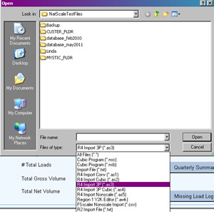

Importing files to the database is done through the **Import** function on the toolbar. Each of the five options offers specific files to import. A browse window opens initially for any option selected. Each file type is listed in the dropdown Files of type box at the bottom.

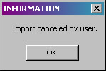

If the **Cancel** button is selected in the browse window, a message indicating the import was canceled is displayed. Click **OK** to close it.

## Import Selection list for FSscaler Program and subsequent optionsFSscaler Program

The FSscaler Program produces an external flat file which can be imported into ScaleExpansion. Three file types are available for importing: Cubic foot volume, Board foot volume and nonscaled loads. When the browse window opens, files with the extension of **.nsc** for cubic foot files or **.nsb** for board foot files are displayed as a default. Nonscaled loads use **.csv** as the extension. Click the filename to import and the process starts. If the format is not recognized by the program, a warning is displayed and the import stops.

## R1 Scale

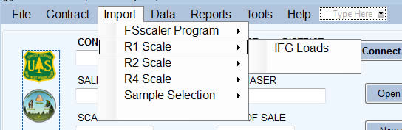The IFG Loads import function for Region 1 applies to mills located in the Idaho Panhandle NF area. These files have an extension of .csv as shown in the browse window when opened. This import checks the log load receipt and lets the user decide if it is to be imported should the receipt not belong to a valid contract. As with other import functions, the error log is updated when errors are detected on import.

## R2 Scale

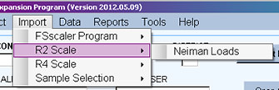On the Black Hills NF, Neiman’s has a program for collecting load information producing a flat file of the data which can be imported. To select a Neiman file, select Import on the toolbar then R2 Scale then Neiman Loads. The browse window opens when this option is selected and uses **.txt** as the default extension. If errors were detected, this import can also display the error log as described above.

## R4 Scale

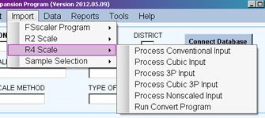Region 4 uses the scale program developed by Electronic Data Solutions. The ASCII text files provided by the data collection routines can be imported into ScaleExpansion.

Region 4 import files offers 6 options. Each has a distinct extension. *Run Convert Program* executes an external conversion program which is not detailed here.

***Process Conventional Input –*** To import conventional scale data for board foot sales, select this option. The default extension is **.as1** and the browse window shows all files of this type. Select the file to import and click **OPEN**.

***Process Cubic Input –*** To import conventional scale data for cubic foot sales, select this option. The default extension is **.as2** and the browse window shows all files of this type. Select the file to import and click **OPEN**.

***Process 3P Input –*** This option imports 3P scale data for board foot sales. The browse window shows all files with **.as3** as the default extension. Select the file to import and click **OPEN**.

***Process Cubic 3P Input –*** This option imports 3P scale data for cubic foot sales. The browse window shows all files with **.as4** as the default extension. Select the file to import and click **OPEN**.

***Process Nonscaled Input –*** Use this option for importing nonscaled loads. The browse window shows all files with **.as5** as the default extension. Select the file to import and click **OPEN**.

If the ASCII files do not exist for the import information, the Convert program (provided by Electronic Data Solutions) needs to be run to extract the information from the data collection program. It is run through ScaleExpansion by selecting *Import* on the toolbar then *R4 Scale* then *Run Convert Program*. When the conversion is complete, control is returned to ScaleExpansion.

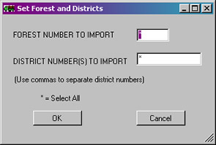After selecting the file to import, the user is prompted to enter the forest and district to import data. The user may select only one forest and district for the import. Alternatively, all forests may be selected by placing an asterisk (*) in the forest number. Multiple districts may be selected by placing a comma between each district number. Preceding zeros must be included. If an asterisk (*) is placed in the district number field, all district data for the selected forest is imported. Click the OK button to start the import.

Each of these processes check for duplicate loads before importing data. When complete, any errors can be viewed and/or printed.

## Sample Selection

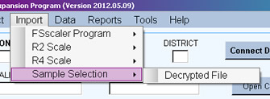The Sample Selection process is a Dynamic Link Library (DLL) developed by the Forest Management Service Center to control the randomness of the sample selection. The DLL can be incorporated into existing sample selection programs at individual mills. The DLL produces an encrypted file which is mailed to the resource clerk. The file must be decrypted before it can be imported. If the program detects the file is still encrypted, a warning message is displayed and requests the file be properly processed before importing. Any errors may be viewed and/or printed when the process is complete.

# TOOLS

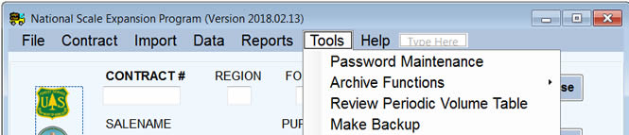

The ***Tools*** option on the toolbar allows **Password Maintenance** and access to **Archive Functions** as well as **Review** of the **Periodic Volume Table**.

## Example of the password maintenance windowPassword Maintenance

Three options are available for passwords: **Add A User**, **Edit Password**, **Remove User**.

When this window is first opened, every field is designated as unavailable. This changes as the buttons at the top are clicked.

***Warning symbolIn order to add or change user information, SYSTEM level access MUST be given to the person making changes.***

***Add A User***

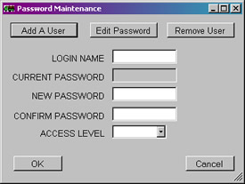Clicking this button makes **Login Name**, **New Password** and the **Confirm Password** fields available. Type in the user’s login name and a password. Confirm the password by typing it in again. Set the **Access Level** from the dropdown list. Click **OK** to accept the changes and close the window. **Cancel** closes the window without saving any changes.

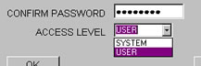

The two choices for Access Level are:

User Level:

May import, enter, and edit scale data.

Create any report.

Change password.

System Level:

In addition to User Level access:

Add new users to the database.

Replace passwords for User Level profiles should a user forget their password.

Remove any User Level profile from the database.

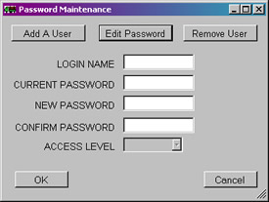***Edit Password***

When this button is clicked, all fields are available except for Access Level. Enter the current login name. Enter the current password if known. **It is not a requirement for the password to be entered.** **But the new password must be entered and confirmed.**  Click **OK** to save the changes. Notification of success is displayed. User and System Level access are allowed to edit passwords.

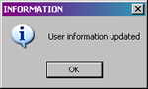

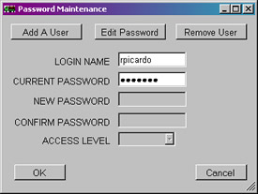***Remove User***

Only two fields are available for removing a user. Enter the login name and current password for the user to be removed. Click **OK** to finish the process. Only System Level access is allowed to remove users from the database.

***Pencil symbolNOTE: Clicking the Cancel button closes the window without saving any changes. Additionally, clicking the X button in the upper right corner closes the window without saving any changes.***

## Archive Functions

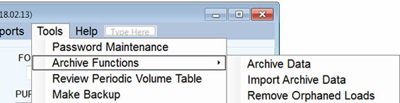

Under **Archive Functions**, three options are available: **Archive Data**, **Import Archive Data**, and **Remove Orphaned Loads**. It is important to have backup data in case something catastrophic happens to the database. However, having multiple copies of the database file has the potential for confusion. It is recommended the **Archive Data** function be used instead.

***Archive Data***

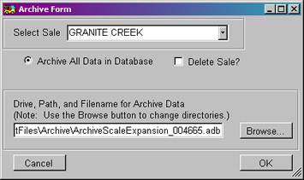This is the standard option to use when making backups of an ongoing sale. All the data from the selected contract is saved in an SQLite database file and placed in a folder titled **Archive**. The default name for the archive file is: ArchiveScaleExpansion_selectedcontract #.db

However, the user has the option to change the filename at the bottom of the window.

Additionally, the sale may be completely deleted by checking the box. Be careful when choosing to delete the sale. This option should only be used when the sale has been closed.

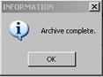

Click **OK** to start the archive process. When complete, the program shows a confirmation message. Click **OK** to close the message.

***Import Archive Data***

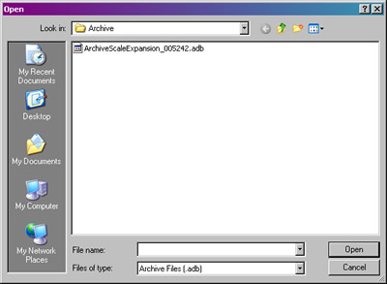When this option is selected, a browse window is opened to select the archive file to be processed. This is essentially the opposite of archiving data. This is importing the data back into the database. To start the process, select the file and click **Open**. The **Cancel** button closes the browse window and no import is completed.

If the contract already exists in the database, the program shows a warning and the import stops. If a log load receipt already exists in the database, the record is skipped. If successful, the program shows an appropriate message.

## Remove Orphaned Loads

An orphaned load is a load imported into a database where there is no other information for that contract. Run the Contract Audit report to determine if there are orphaned loads. Load receipt numbers which do not belong to any of the defined contracts show up in this report.

This option shows the browse window where the user types in or locates the output file to use for the orphaned load information. If orphan loads are detected, records pertaining to those loads are written to this output file and deleted from the database. The file can then be mailed to the correct Forest for input into the correct contract or the file can just be deleted. If no orphan loads are found, the program displays an appropriate message.

## Review Periodic Volume

*Click this button to close the window.*

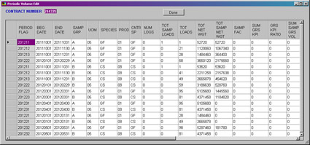

*All records are displayed here.*

*Use the mouse to pull this corner to make the window bigger.*

*Use the scroll bar to move list back and forth.*

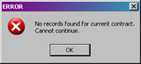

To review periodic volume data, select *Tools* from the **Main Menu** toolbar and then select *Edit Periodic Volume Data*. If there is data to review, this window is displayed. If no data exists for the contract, a warning message is displayed and can be closed by clicking **OK**.

**Data in this window cannot be modified or added.** There are several fields displayed and the window can be resized to view all columns. Use the mouse to drag the lower right corner to resize the window. Alternatively, drag the scroll bar at the bottom right or left to see the remaining columns.

When the review is complete, click the **Done** button to close the window.

**Warning symbolNOTE: Clicking the X button in the upper right corner also closes the window. However, no confirmation window is displayed and no data is saved.**

***Data Fields for the Period Volume Table***

***Contract –*** Contract number assigned to the sale.

***Period Flag –*** First four digits are the fiscal year. The next digit (one) represents the quarter, i.e. 1 for first quarter. The last digit (one) represents the month within the quarter, i.e. 2 for the second month in the quarter. For example, 201222 represents fiscal year 2012, second quarter, February (second month).

***Beg Date –*** Beginning date for the selection of hauled and sampled loads.

***End Date –*** Ending date for the selection of hauled and sampled loads.

***Samp Grp –*** Sample group identifier.

***UOM –*** Unit of measure code.

***Species –*** Species code.

***Prod –*** Product code.

***Cntr Sp –*** Contract species code.

***Num Logs –*** Number of sampled logs.

***Tot Samp Loads –*** Total number of sampled loads for the selected data range.

***Tot Loads –*** Total number of hauled loads for the selected data range.

***Tot Net Wgt –*** Total net weight for all of the hauled loads.

***Tot Samp Net Wgt –*** Total net weight for all of the sample loads.

***Samp Fac –*** First stage sample factor. This is either the total number of loads divided by the total number of sample loads or is the total net weight for all the loads divided by the total net weight for the sample loads.

***Sum Grs KPI –*** Sum of the gross KPIs. 3P scale method only.

***Grs KPI Ratio –*** Gross ratio between the gross KPIs and the gross scaled volumes. 3P scale method only.

***Sum Samp Grs Vol –*** Sum of the expanded sample gross volume for a 3P scale.

***Sum Grs STM Vol –*** Either the sum of the sure-to-measure gross volumes for a 3P scale or the sum of the gross volumes for a conventional scale.

***Tot Grs Vol –*** Total gross volume cut for the range of data selected.

***Net KPI Ratio –*** Gross ratio between the gross KPIs and the net scaled volumes. 3P scale method only.

***Sum Samp Net Vol –*** Sum of the expanded sample net volume for a 3P scale.

***Sum Net STM Vol –*** Either the sum of the sure-to-measure net volumes for a 3P scale, the sum of the net volumes for a conventional scale, or the computed net volume using the weight factor for a weight scale.

***Total Net Vol –*** Total net volume for the range of data selected. This is either the quarter-to-date or contract-to-date volume depending on whether the sale is an Escalated or Flat Rate sale.

***Total Def Vol –*** Total defect volume for the range of data selected. This is either the quarter-to-date or contract-to-date volume depending on whether the sale is an Escalated or Flat Rate sale.

***Total Grs Vol –*** Total gross volume for the range of data selected. This is either the quarter-to-date or contract-to-date volume depending on whether the sale is an Escalated or Flat Rate sale.

***Period Net Vol –*** The total net volume cut for this period. This is the net volume reported in the TSA transaction file. This could be a negative number.

***Period Grs Vol –*** The total gross volume cut for this period. This could be a negative number.

***Period Def Vol –*** The total defect volume cut for this period.

## Make Backup

Even though the T drive is supposed to function as a backup storage location for the database file, it can happen that communication with the drive is interrupted during the copy between the user computer and the drive causing data to be lost. The **Make Backup** option under **Tools** allows the user to make an additional backup on the local computer C drive. Follow the steps below to create the backup file:

1. Start the ScaleExpansion program normally.
2. Open the desired database. *NOTE: A database file must be opened to perform the backup.*
3. Click on **Tools** from the Main Menu toolbar.
4. Click on **Make Backup** in the list.
5. 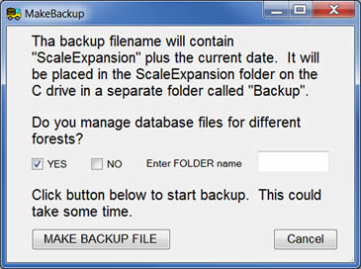On the next display, read the instructions provided before starting the backup.
6. Two things to keep in mind:
   1. If multiple forests are managed, a backup for each can be created.
   2. Click **Yes** and a text box appears where the **FOLDER** name for the forest can be entered. It **MUST** be the folder name and not the forest name.
   3. Click the **Make Backup File** button.
   4. The backup is placed in the following directory:
      1. C:\fsapps\ScaleExpansion\Backup\<forest folder name>
      2. 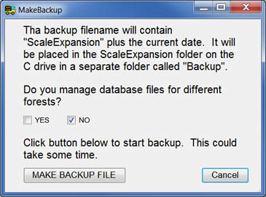The filename is “ScaleExpansion_” plus the current date ending with “.db”.
   5. If multiple forests are **NOT** managed, simply click the **Make Backup File** button.
   6. The filename used is the same as described above.

How can the backup file be restored? Simply navigate to the appropriate folder and copy the backup file to the T drive. Rename the file by removing the underscore and the date. When the program is opened on the local computer, this file is copied back to the C drive on the local computer.

# Appendix A – Reports

| **REPORT CATEGORY** | **REPORT TITLE** | **CONTRACTS** | **FILENAME** |
| --- | --- | --- | --- |
| Summary | Contract Summary | All contracts selected | Contract_Summary.txt |
|  | All Load Summary (with or without sample groups) | All contracts selected | All_Loads_Summary.txt |
|  | All Load Summary (with or without sample groups) | Single contract | Load_Summary.txt |
|  | Scaled Load Summary | All contracts selected | All_ScaleLoad_Summary.txt |
|  | Scaled Load Summary | Single contract | ScaleLoad_Summary.txt |
| Audit | Contract Audit | All contracts | Contract_Audit.txt |
|  | Tickets Issued Audit by Log Load Receipt | All contracts selected | All_Ticket_Audit_LLR.txt |
|  | Tickets Issued Audit by Log Load Receipt | Single contract | Ticket_Audit_LLR.txt |
|  | Tickets Issued Audit by Book Number | All contracts selected | All_Ticket_Audit_Book.txt |
|  | Tickets Issued Audit by Book Number | Single contract | Ticket_Audit_Book.txt |
|  | Sample Load Audit | All contracts selected | All_SampleLoad_Audit.txt |
|  | Sample Load Audit | Single contract | Sample_Load_Audit.txt |
|  | Sample Group Audit | All contracts selected | All_SampGroup_Audit.txt |
|  | Sample Group Audit | Single contract | SampGroup_Audit.txt |
|  | Duplicate Load Check | All contracts selected | All_DupCheck.txt |
|  | Duplicate Load Check | Single contract | DupCheck.txt |
|  | AllLoads CSV File | All contracts selected | All_Loads.CSV |
|  | AllLoads CSV File | Single contract | Loads.CSV |
| Period | Periodic Volume | All conventional sales | All_Period_Conv.txt |
|  | Periodic volume | All weight sales | All_Period_WT.txt |
|  | Periodic Volume | All 3P sales | All_Period_3P.txt |
|  | Periodic Volume | Single conventional sale | Period_Conv_contr#.txt |
|  | Periodic Volume | Single weight sale | Period_WT_contr#.txt |
|  | Periodic Volume | Single 3P sale | Period_3P_contr#.txt |
| Quarterly | Quarterly Summary | One or more | Volume_Statement.txt |
| Frequency | Frequency Calculation | Single contract | FreqErr_contr#.txt |

## REPORT EXAMPLES

These examples are for a single contract. Reports with multiple contracts look the same just more contracts in the report.

*Contract Summary*

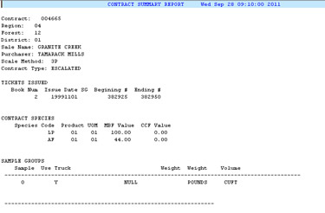

*Load Summary*

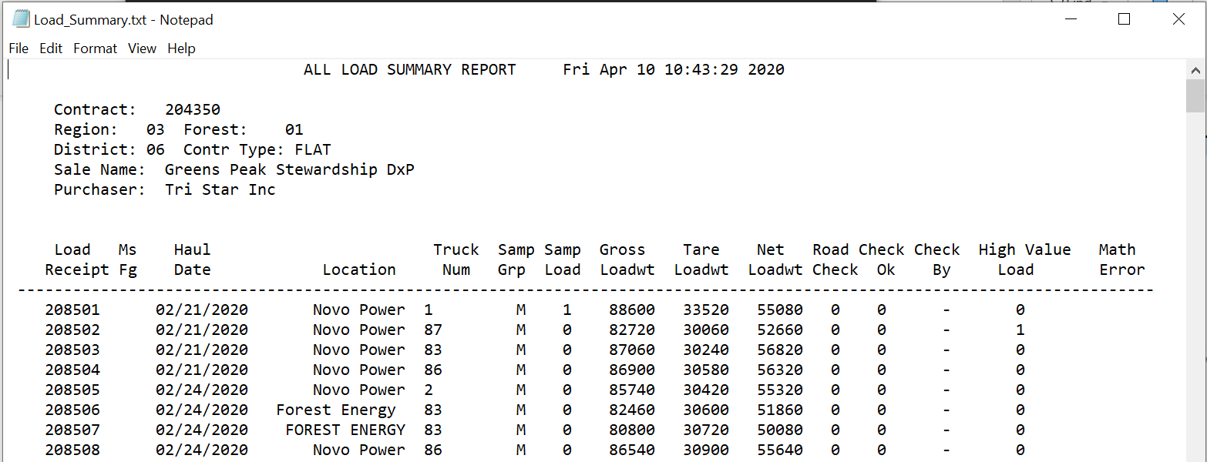

*Scaled Load Summary*

*(shown in two parts)*

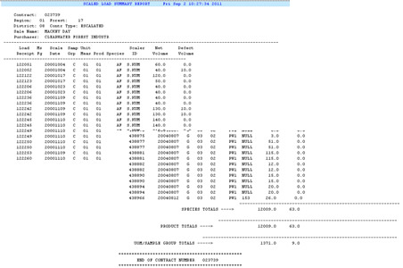

*Contract Audit*

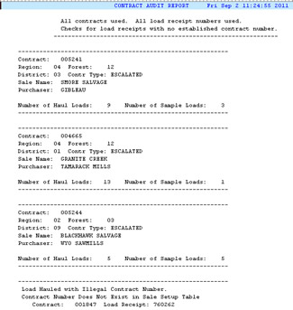

*Ticket Audit by Log Load Receipt*

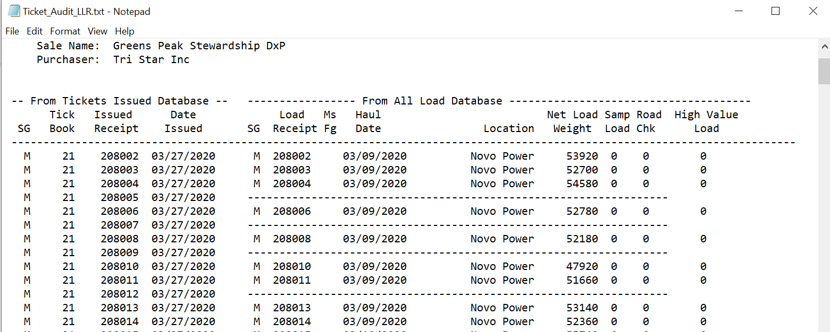

*Sample Load Audit*

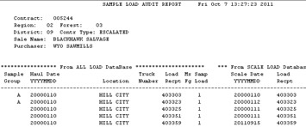

*Sample Group Audit*

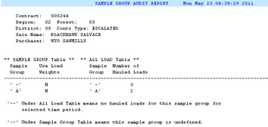

*Duplicate Check (no duplicates)*

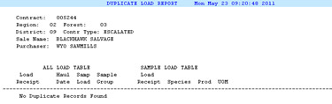

*Duplicate Check (duplicates)*

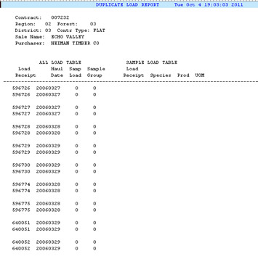

*Period Volume*

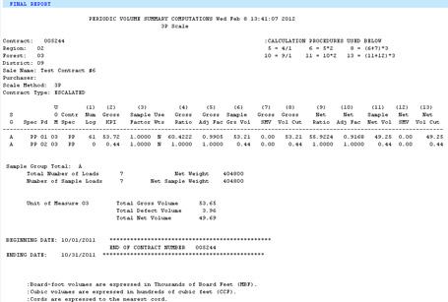

*Quarterly Summary*

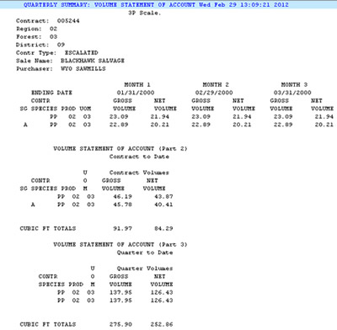

*Frequency Error*

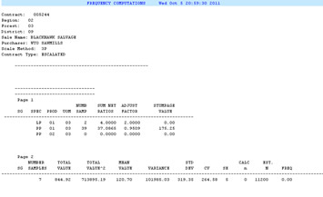

# Appendix B – Set Dates

The **Set Dates** window is used to set a range of dates to include in either reports or other selections. There are three possible forms to the window as discussed here.



This first layout is used when only the fiscal year and quarter need to be set. The fiscal year is a two-way list, going up from the current year displayed or down in time. Use the little arrows to move the years. The quarter is selected by clicking the button for quarter desired. First quarter is October to December, second is January to March, third is April to June, and fourth is July to September. When the quarter is selected, the beginning date is set to the first day in that quarter except for Flat Rate sales. In that situation, the beginning date is the first day with the first hauled load.

When the selection is complete, click the **Continue** button and the range of dates is applied to the situation. The **Cancel** button closes the window without saving any changes.

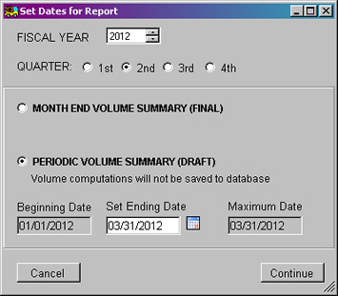

The next layout for this window is **Set Dates for Reports**. As in the window above, the fiscal year and quarter are selected at the top. The bottom portion is primarily for reports such as the Periodic Volume Summary.

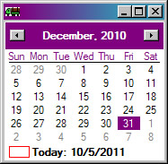The **Periodic Volume Summary** at the bottom is for the draft version which does not update the database with the volume calculations. Beginning and ending dates are shown with only the ending date accepting changes. When the little calendar button is clicked, a small calendar is displayed so dates can be easily selected. Only the months for the current quarter are available.

Click the **Continue** button to save the changes and apply the range of dates to the report. The **Cancel** button closes the window without saving changes made.

The third layout for the window is when **Month End Volume Summary** is clicked. This is used when the volume summary is complete and the final version of the report is to be created. After the quarter and fiscal year are selected and Month End Volume Summary clicked, the list of months in the quarter is displayed. Any of the three months in the selected quarter may be selected for the report.

Click **Continue** when the selection is complete. The **Cancel** button closes the window without saving the changes.

# Appendix C – Scale Sync

Listed below are the instructions for installing the Scale Sync program. Anyone can use this script and the instructions are detailed enough to modify for any user. It is recommended that databases used with the ScaleExpansion NOT reside on the T or O drive. The program does run on databases located on the T or O drive but like many server connections, it is not very speedy. However, these drives are a great place to backup the database files. But it is recommended to run ScaleExpansion against database files residing on your local PC drive, probably the C drive. Anyway, here are instructions for using the script file if you choose to use this particular method for file management.

**BACKGROUND:**

It is Region One policy that ScaleExpansion data is to be stored on a Forest Service server and not stored on the user’s PC (or C: Drive). This policy ensures the data is available to other users, is not lost if the PC fails, and if needed can be restored from the server backup.

There are certain circumstances where it is desirable for the database to be on the local PC, particularly if the user is working in a location with a slow network connection, and we are finding that is the case with the T: Drive.

In order to meet this need, Region One has created a system for allowing the database to be stored on the PC, while maintaining a current copy on the Forest Database located on the T: Drive server. Additionally, this system locks the server copy if a user has the ScaleExpansion application open, preventing two users from editing the data at the same time and one user overwriting another user’s changes.

**HOW THE SCALE SYNC SYSTEM WORKS:**

* A user clicks on the icon to start ScaleExpansion
* The application checks to see if the database is locked by another user. If this is the case the application exits.
* If the database is not in use by another user, the database located on the T Drive server is copied to the database located on your C Drive.
* The server copy is then locked. A file called “.LCK” appears in the directory.
* ScaleExpansion is opened, and the user connects to the C Drive database.
* User enters data as usual into ScaleExpansion.
* When user exits ScaleExpansion, the changes on the C Drive database are copied to the database on the T: Drive server. This includes reports as well.
* The lock to the server database is removed.

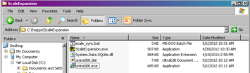**HOW TO INSTALL SCALE SYNC:**

1. The scale_sync.bat file is installed in the ScaleExpansion folder in the fsapps directory when the program is installed.
2. Next, navigate to the server database folder which is located on the T: Drive.
3. If the user manages more than one database make sure each database folder has been named to indicate the specific Forest or District database. It is very important to keep the databases separate on the C: Drive and the T: Drive.

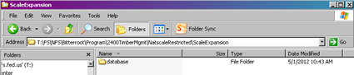

1. Right click on the T: Drive database folder and select copy. In this example we are copying the database folder **NatscaleRestricted\ScaleExpansion\database**

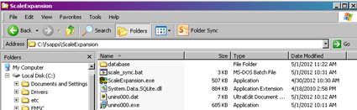

1. Browse to **C:\fsapps\ScaleExpansion**, and paste the database folder here.
2. Next, right click on the ScaleExpansion icon located on your desktop.

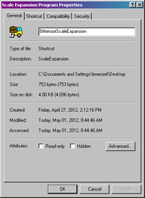

1. Select properties. If managing more than one database you need to change the shortcut title to indicate the Forest/District database you work with. This adds the name under the icon on your Desktop.

Do this under the **General** tab.

1. This step ties together the scale_sync application with both the C: Drive database and the T: Drive server database. Under the **Shortcut** tab you will need to change the target. You will enter three separate directory pathnames all on one line in the **Target** box. **Make sure to add one space between each directory pathname:**
   1. 1st pathname: C:\fsapps\ScaleExpansion\scale_sync.bat
   2. 2nd pathname: C:\fsapps\ScaleExpansion\database (if you added your Forest or District name to the database folder name add that name here)
   3. 3rd pathname: T:\FS\NFS\<Forest_Name>\Program\2400TimberMgmt\NatscaleRestricted\ScaleExpansion\database

Your pathname will look like this (all on one line, of course):

**C:\fsapps\ScaleExpansion\scale_sync.bat C:\fsapps\ScaleExpansion\database T:\FS\NFS\<Forest_Name>\Program\2400TimberMgmt\NatscaleRestricted\ScaleExpansion\database**

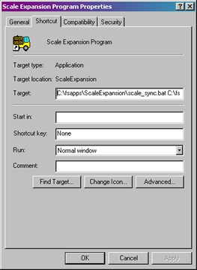**(You can edit the above pathname to add your <Forest_Name> then copy and paste into the Target box)**

1. Select **Apply,** and then **OK** to close the window.
2. You will see the desktop icon for ScaleExpansion has changed. We need to get the “truck” icon back.

Program icon with gear instead of truck

1. To get the truck icon back right click the icon, select properties.
2. Under the **Shortcut** tab select the **Change Icon** button.

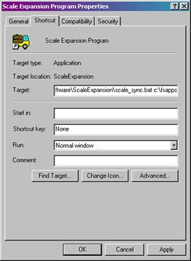

The following box will appear, click **OK**:

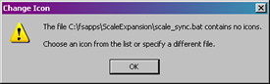

1. Browse to **C:\fsapps\ScaleExpansion\ScaleExpansion.exe** through the following two windows:

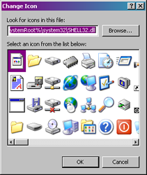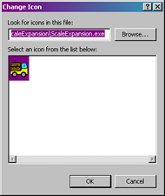

1. Select **Apply**, then **OK**.

You have completed the Scale Sync installation process for one Forest database. If you manage more than one Forest database repeat steps 4 through 14 for each. You need a ScaleExpansion icon on your desktop for each database you manage.

You are now ready to use the Scale Sync program for ScaleExpansion!

**USING THE SCALE SYNC PROGRAM:**

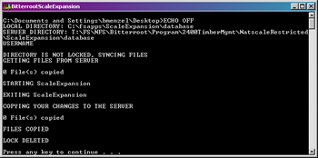When you click on the ScaleExpansion icon the sync process starts and ScaleExpansion opens. When the Scale Sync process starts a window appears like the one below. Do not close this window because it is part of the sync process. When you see the words “STARTING ScaleExpansion” at the bottom of the window the database on the T: Drive server is locked for entry by others and the ScaleExpansion database on the C: Drive is ready for your use.

The ScaleExpansion Program opens at the same time. Browse to **C:\fsapps\ScaleExpansion\database** and open the **ScaleExpansion.db** file to connect to the database. You are now working on the C: Drive database.

You should see a marked improvement in the speed of your transactions.

When you are done entering your loads and generating reports you can exit ScaleExpansion as normal.

Once you exit ScaleExpansion, the program copies the database files from the C: Drive to your T: Drive server database. Pay close attention to the lines of data. If you see any error messages you know something didn’t work properly.

The server database is now unlocked and ready for use by other authorized users.

If the ScaleExpansion program should close unexpectedly (like a power outage), the .LCK file may still show in the directory even though the file is no longer technically locked. To correct this, simply delete the .LCK file and then verify whatever was added prior to the interruption was actually added or modified. It may be necessary to revert to a backup of the database file. You do make backups of the database file, right?

**Important note:** For users who manage multiple Forest databases make sure you connect to the database associated with the Shortcut Icon. If not your ScaleExpansion updates will be lost. For example: If you open ScaleExpansion with the **BitterrootScaleExpansion** icon and then you connect to the **CLWScaleExpansion** database the Bitterroot Forest database will be synced and you will lose your changes to the Clearwater Forest database.

Region 1 users -- If you have questions call Margie Fuchs at 406-329-3386, email: [mfuchs@fs.fed.us](mailto:mfuchs@fs.fed.us)

Region 2 users – Contact Kurt Stagner at 970-874-6614, email: [kstagner@fs.fed.us](mailto:kstagner@fs.fed.us)

Region 3 users – Contact Karen Jones at 505-842-3420, email: [kajones@fs.fed.us](mailto:kajones@fs.fed.us)

Region 4 users – see contacts list at beginning of this guide.

ScaleExpansion User Guide.docx

Created: October 2011

Modified: March 2012

Modified: April 2012

Modified: May 2012

Modified: July 2012

Modified: August 2012

Modified: June 2013

Modified: January 2018

Modified: February 2018

Modified: April 2020