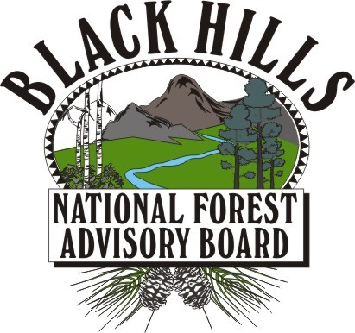

Advisory Board Meeting
Forest Service Center

8221 S. Hwy 16, Rapid City, SD 57702
1:00 p.m. to 5:00 p.m. – February 19, 2014

Time | Item | Presenter
1:00 | Introduction and Welcome | Craig Bobzien, Forest Supervisor and Federal Advisory Committee Designated Federal Official (DFO)
 | Approve Minutes of January 8, 2014 Meeting | Chairman Scherrer
 | Approve the Agenda | Chairman Scherrer
 | Housekeeping | DFO Bobzien
 | Comments to the Chair | DFO Bobzien
 | Meeting Protocols | Chairman Scherrer
 | Hot Topics  - Legislative Updates – Federal  - Legislative Updates – State | SD - Haugen, Blair, Holt  WY – Kay, Jones  SD - Sen Tieszen  WY – Commissioner Whalen
 | Regular Agenda:  2013 Forest Health Survey (bug flight)  Motorized Travel Working Group Update  Appointment of Recreational Facilities Working Group  Forest Plan Brief  2103 Forest Monitoring Report  Appointment of Forest Health Working Group (MPB)  Membership and Charter-Renewal Update | Craig Bobzien, Kurt Allen  Derek Larsen – Spearfish Forest Products  Tom Blair  Craig Bobzien  Ed Fischer  Ed Fischer / Dave Mertz  Craig Bobzien  Scott Jacobson
 | Public Comments  - If time allows, at the conclusion of the meeting, public comments will be taken, limited to three minutes per person. | Chairman Scherrer
NTE  5:00 | Adjourn  - The meeting will adjourn promptly at or before 5:00 p.m. | Chairman Scherrer

