Birding on the Bankhead National Forest

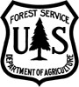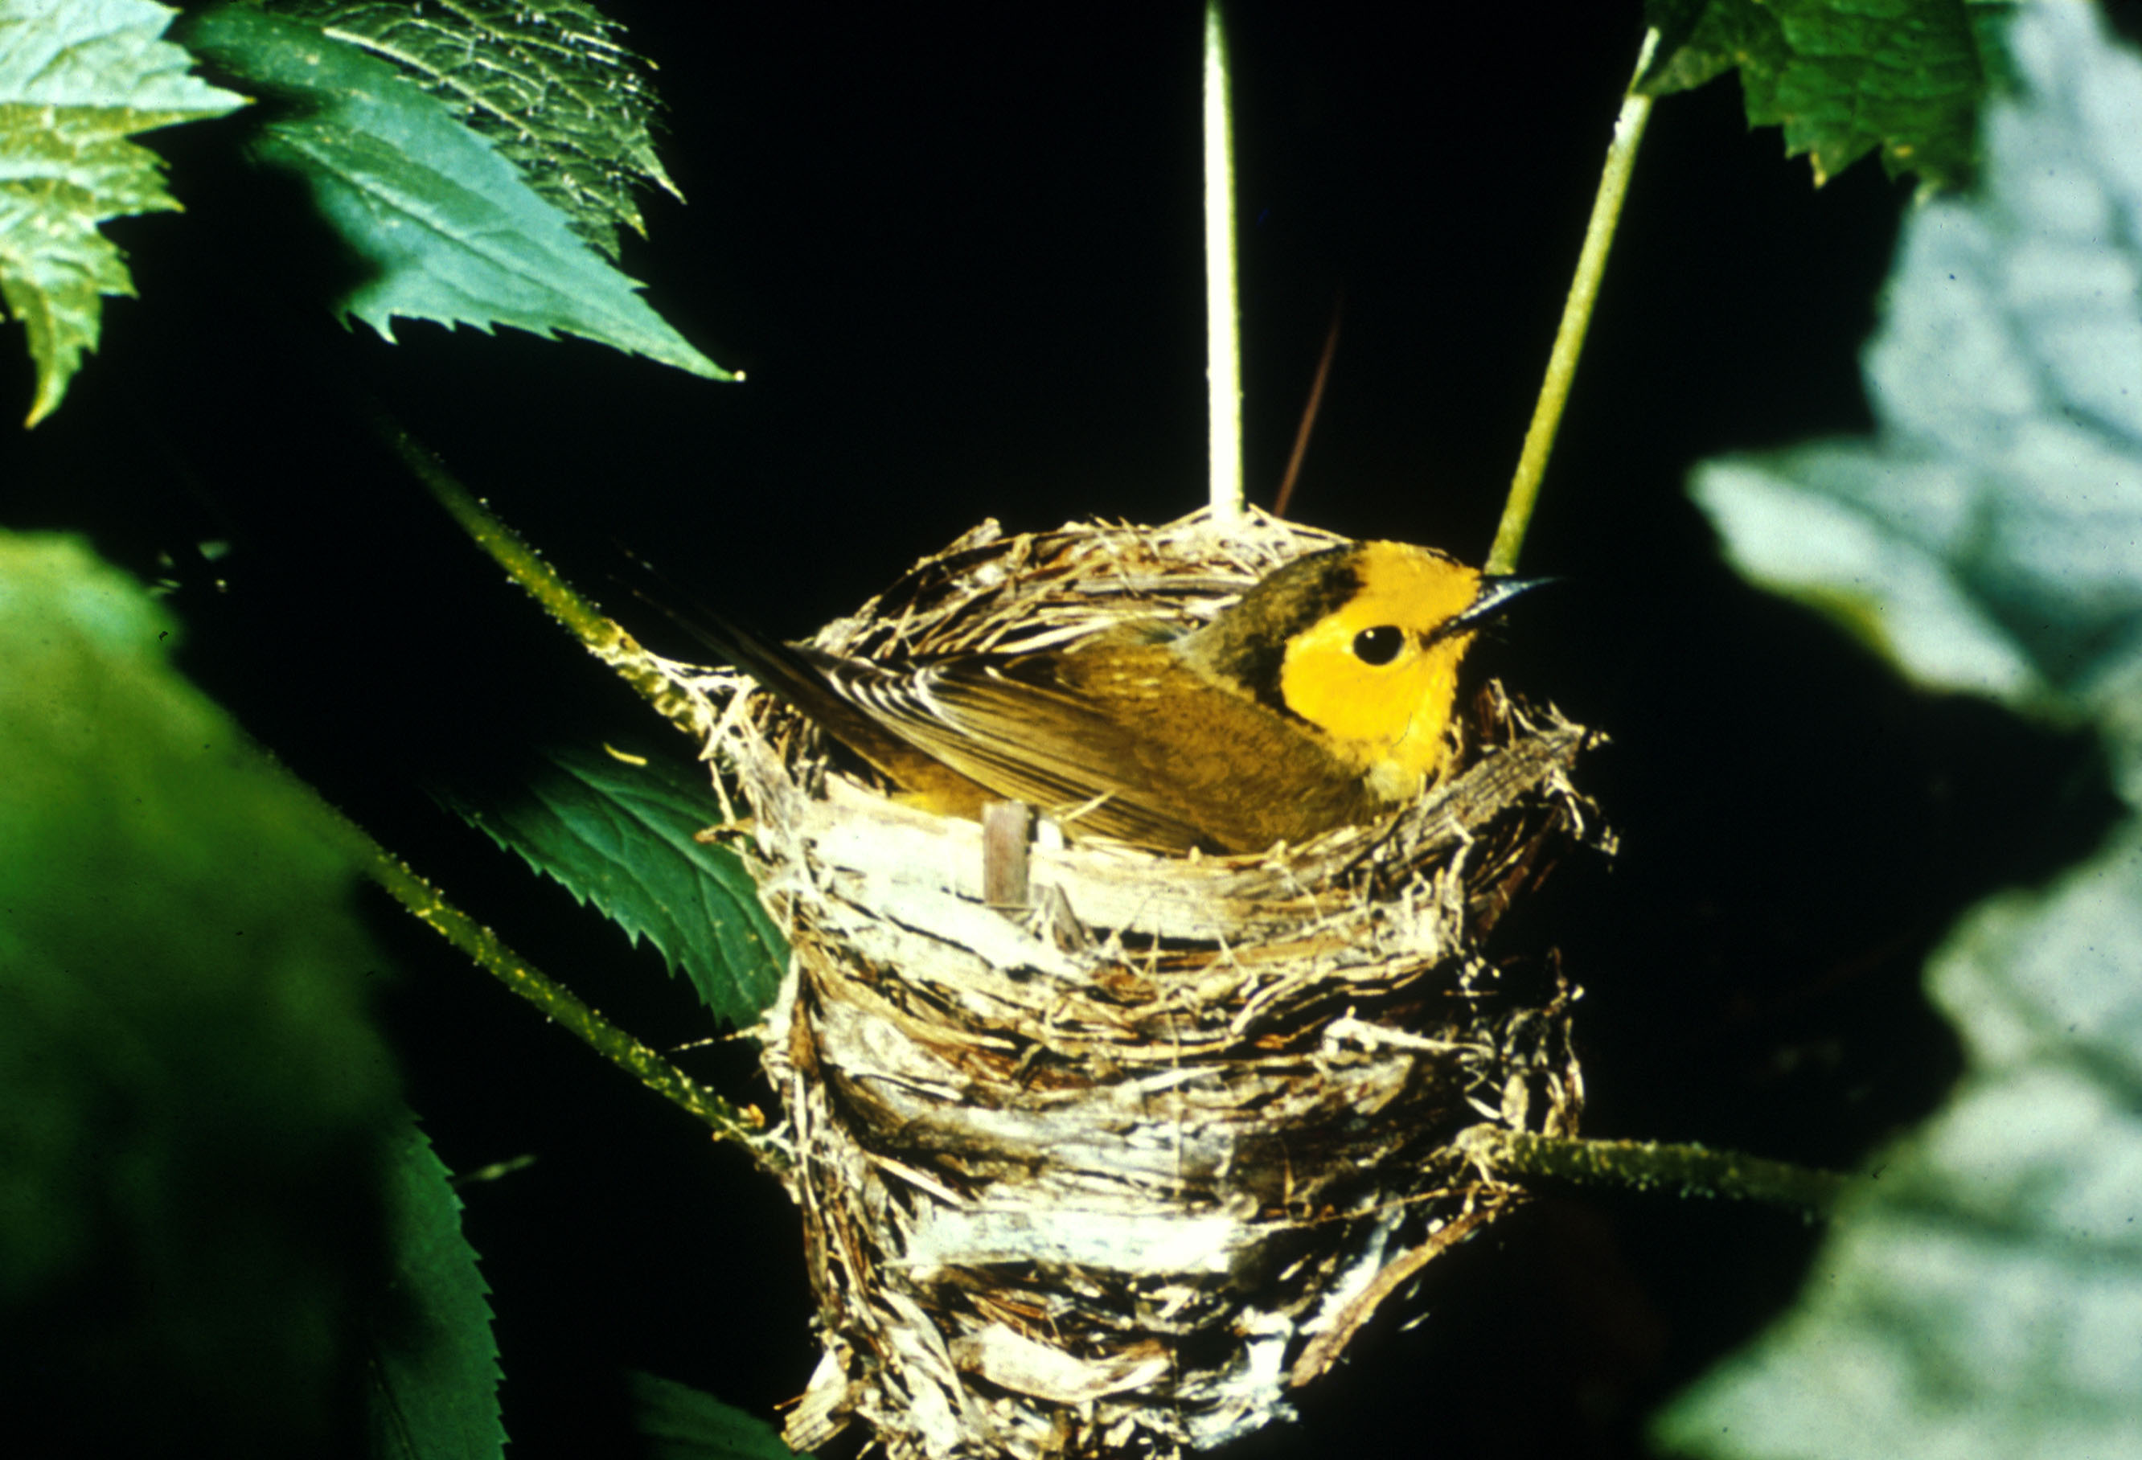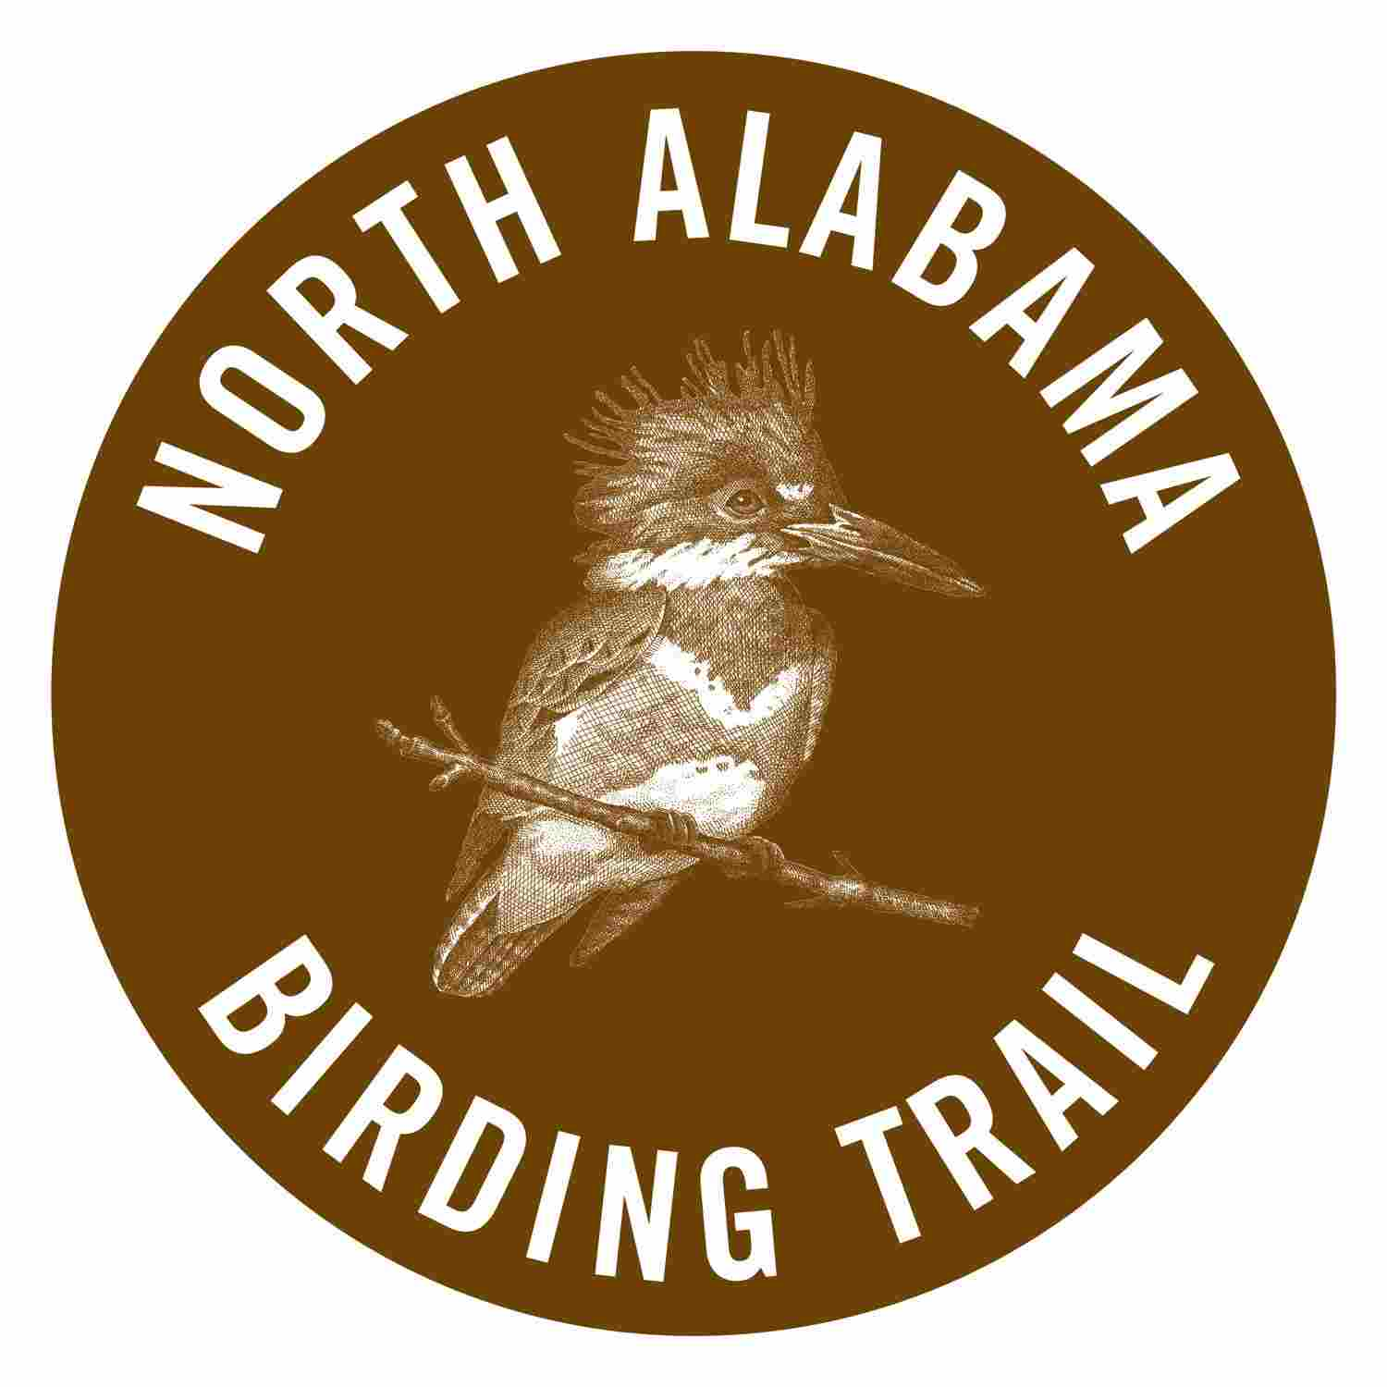

Discover the Incredible Variety of Habitats and Birds in the Bankhead National Forest

William B. Bankhead National Forest is located in Lawrence, Winston and Franklin counties within the Cumberland Plateau region of North Alabama. Spread over 180,000 acres, the Bankhead provides habitats for many native wildlife and plants species, including many rare species that are uncommon or not found many other places in the country. The Bankhead National Forest offers vast opportunities for bird watching. Bird activity is highlighted by early spring migration and late spring to early summer nesting season.

The large expanses of forests found in the Bankhead are not common across northern Alabama. The USDA Forest Service emphasizes maintaining a diversity of forest communities that are not abundant on private lands in the Cumberland Plateau. The large, continuous and diverse nature of the forests is a significant feature of the Bankhead and is why so many birds are found here. This nature of the Bankhead, a continuous expanse of forested habitat, is why the American Bird Conservancy designated the Bankhead National Forest as an Important Bird Area. It is also why the Bankhead is part of the North Alabama Birding Trail. Bankhead’s bird diversity reflects the diversity of habitats here. Eighty-four species of birds have been recorded during the breeding season.

Come explore the various habitats and bird species found in each one. And, come learn about forest management in the different types of forests on the Bankhead.

Visit the Ranger Station on Highway 33 in Double Springs where you can get oriented to the Forest, review maps, identify areas to go birding, pick up a birding brochure and checklist, and find out what birds have been seen lately. Or, call the Bankhead National Forest at (205) 489-5111 for more information.

North Alabama Birding Trail on Bankhead

Begin your visit at the Central Firetower Kiosk Site for the North Alabama Birding Trail on Bankhead.
Directions to the Central Firetower Kiosk Site:
From the intersection of AL Hwy 24 and AL Hwy 33 in Moulton, head south on Hwy 33 for 11.4 miles into the Bankhead. The kiosk is located near the firetower at mile marker 15.

Site 1 - Walston Ridge Road
The road along Walston Ridge provides some of the best birding on the Bankhead National Forest due to a variety of forest habitats found here. Along this road you will see the evidence of prescribed fire that is utilized to maintain the open character of the upland forest. The forests here are upland oak-pine woodlands. As you proceed down the road you will also find wildlife openings, young pine forest and riparian coves and creeks. You might see a blue-winged warbler, prairie warbler or a yellow breasted chat. The road ends just above Collier creek…walk down into this cove forest to listen for a Louisiana Waterthrush or an Acadian Flycatcher.
Directions to Walson Ridge Road:
From the Central Firetower, go south on AL Hwy 33. Bear left on County Road 63. Turn left onto Forest Service Road 245. Turn right onto Forest Service Road 253 (Walston Ridge).

Site 2 - Brushy Lake Recreation Area
Brushy Lake provides overnight camping and day use facilities along the wooded shores of a lake. Be on the lookout for an osprey, swallows, wood duck or kingfisher at the pier. Follow the trail downstream to get a glimpse of the cove forest with its bluffs and rushing stream where you may hear a worm eating warbler. Explore upstream and you will find a switchcane thicket along the creek and you may hear a Swainson’s Warbler.
Directions to Brushy Lake:
From the Central Firetower, go north on AL Hwt 33. Turn right onto Forest Service Road 246/Co Rd 70. Turn left on Forest Service Road 245. Turn right into Brushy Lake Day Use Area.

Site 3 - Northwest Road
Travel along the Northwest Road provides a beautiful drive any time of the year. The road winds around sheer rock bluffs and along limestone rock outcrops through a forest cover of cedar woodlands and mature hardwood forests. The karst, limestone topography of this area influences the forest vegetation in many ways. In this area you could hear scarlet tanager or see a black throated green warbler or even a Kentucky Warbler.
Directions to Northwest Road:
From the Central Firetower, go south on AL Hwy 33. Turn right onto Forest Service Road 208/NW Road at mile marker 14.

Site 4 - Sipsey Wilderness Trailhead
This trail follows the Sipsey Fork, a designated Wild and Scenic River corridor. The trail goes through an extensive mature hardwood forest within the Sipsey Wilderness. This area is famous in Alabama for its nesting Cerulean Warblers. This is a stronghold for the species within the state and possibly one of the best places to see these dazzling jewels.
Directions to Sipsey Trailhead:
From the Central Firetower Kiosk, go 2.5 miles south on AL Hwy 33. Turn right onto Co Rd 60/Cranal Road and follow it for 3.9 miles to the Sipsey Wilderness Trailhead, located at the Sipsey River Picnic Area.

